PRE

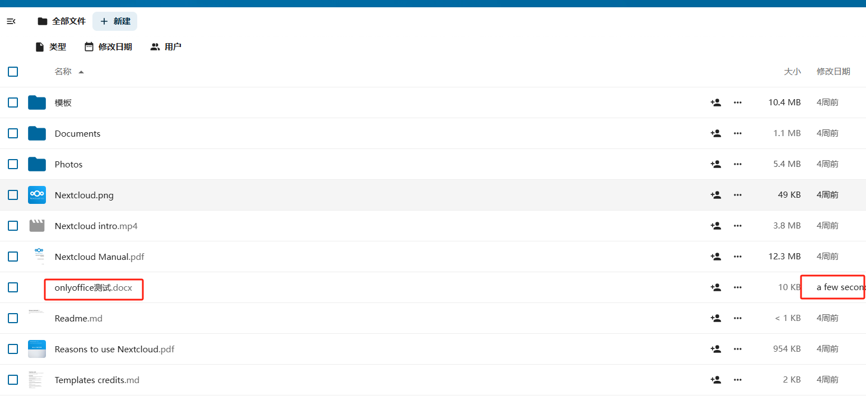

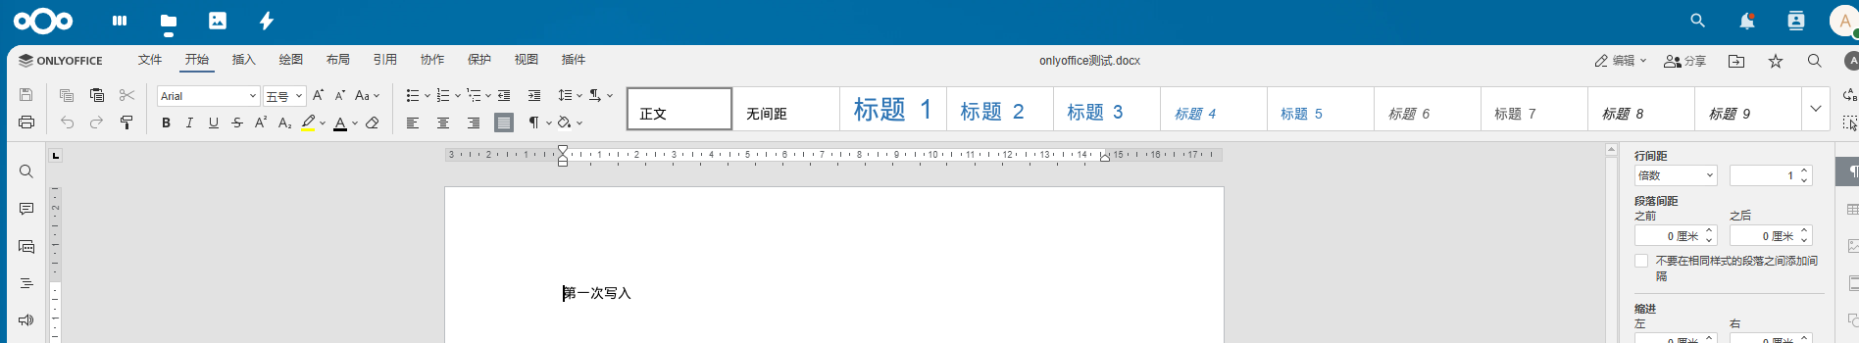

Edit the docfile

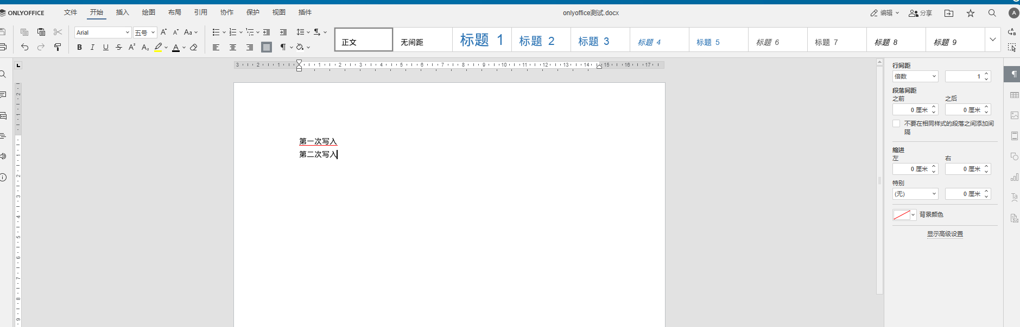

After downloading the file, it was found that the previous version was downloaded and the modification time of the file was also earlier. The modified version in only office still exists in only office and has not been saved to the local storage of the cloud drive