 | 部门  Department | 姓名  Name | 签名  Signature | 日期  Date
起草  Prepared by | EE | 罗青山 | 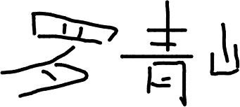 | 2024-04-30
审核  Reviewed by | EE | 万成波 | 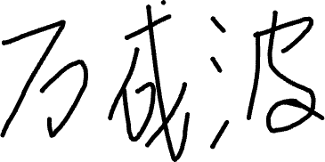 | 2024-05-06
 | PD | 徐瑞 |  | 2024-05-06
 | QA | 苏珏 | 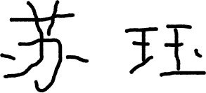 | 2024-05-09
批准  Approved by | QA | 苏珏 |  | 2024-05-09

生效日期 Effective Date：2024-05-10

电子表格编号Electronic Form No.：
技改项目
Project of Technical Upgrading
□设备Equipment  □设施Facilities | 名称  Name |  | 编号  No.
改造过程说明
（可附附件）
Description of the upgrading Process (Annex can be attached)
改造预算费用
Summary of the upgrading budget
实际效果评估
（可附附件）
Actual effect evaluation
(Annex can be attached)
设备工程部审核意见
Comments of EE
相关部门审核意见  Comments of Relevant Department | □QA □EHS
是否进行再确认？  Re-verification? | □是Yes，再确认报告编号Re-Verification Report No.：  □否No
使用部门审核意见
Comments of Use Department

