Name: __________________________________ Date:_____________________ Block:____________

**Gas Laws Packet #2 Chapter 12.2 Gas Laws ver 12-14-23**

Starter: The 4 measurements needed to describe the gas in the Nalgene bottle are listed below. In terms of particles what does it mean to hold these variables constant?

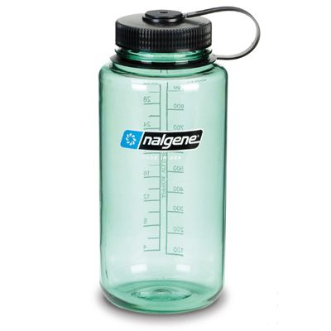

* Volume
* Temperature
* Number of particles (moles), mass
* Pressure

Constant volume - **same amount of space for particles to move in.**

Constant temperature - **same average speed for the particles.**

Constant mass **- same number of particles, same number of moles of particles**

Constant Pressure - **same force ( both speed and mass of particles) and number of collisions with the walls of the container.**

**Section 12-2: The Gas Laws  
 (p. 323-432)**

**Objectives**

**1. Use the kinetic-molecular theory to explain the relationships between gas volume, temperature, and pressure.**

**2. Use Boyle’s law to calculate volume-pressure changes at constant temperature.**

**3. Use Charles’s law to calculate volume-temperature changes at constant pressure.**

**4. Use Gay-Lussac’s law to calculate pressure-temperature changes at constant volume.**

**5. Use the combined gas law to calculate volume-temperature-pressure changes.**

**Boyle’s Law**

**Sample Data - Is the data directly or inversely proportional?**

|  |  |  |  |
| --- | --- | --- | --- |
| Volume (mL) | Pressure (torr) | P * V = k | P/V = k |
| 10.0 | 760.0 |  |  |
| 20.0 | 379.6 |  |  |
| 30.0 | 253.2 |  |  |
| 40.0 | 191.0 |  |  |

**avg.**

**Conclusion:**

**Graph the data below:**

**3 Characteristics of Inversely Proportional Data**

1. Graph of data produces a curved graph called a hyperbola

2. P * V = k (constant)

3. As Volume doubles, Pressure cut in halve and vice versa

**Boyle’s Law Summary!**

**Boyle’s law** - The pressure and volume of a gas are inversely related

* at constant mass & temp

**P*V = k (constant) or P1V1 = P2V2**

**Examine the diagrams and answer the questions!**

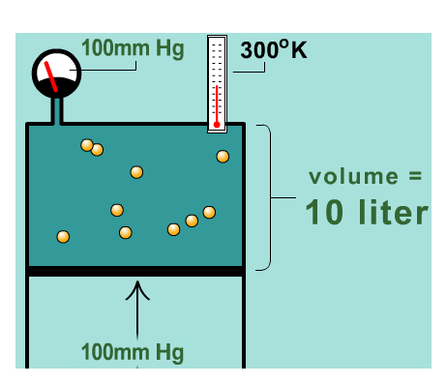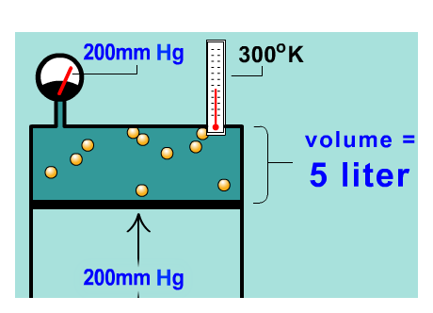

1. What 2 variables are held constant in this diagram?

2. What 2 variables are changing and what are their values?

3. What happened to the pressure and volume?

4. Use the KMT and particles to explain why the pressure doubles when the volume is halved at constant temperature and mass?

**The KMT states that all matter is constantly moving. At constant temperature all of the particles are moving at the same speed and the number of particles are the same at constant mass. When the volume is cut in half the have to travel half the distance before striking the walls. The particles hit the walls twice as frequently which doubles the pressure.**

**Charles’ Law**

**Sample Data - Is the data directly or inversely proportional?**

|  |  |  |  |
| --- | --- | --- | --- |
| Temperature (K) | Volume (mL) | V * T = k | V/T = k |
| 273.2 | 40.0 |  |  |
| 298.2 | 44.0 |  |  |
| 323.2 | 47.7 |  |  |
| 547.9 | 80.0 |  |  |

**Conclusion:**

**3 Characteristics of Directly Proportional Data**

1. Graph of data produces a straight line.

2. V/ T = k (constant)

3. As Temperature doubles, Volume doubles and vice versa

**Charles Law Summary**

**Charle’s Law - The volume and absolute temperature (K) of a gas are directly related**

**at constant mass & pressure**

**V / T = k (constant) or** 

**Examine the diagrams and answer the questions!**

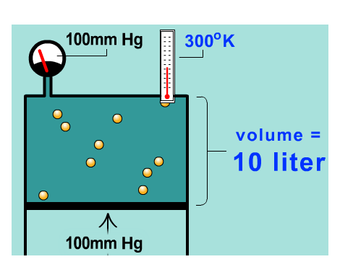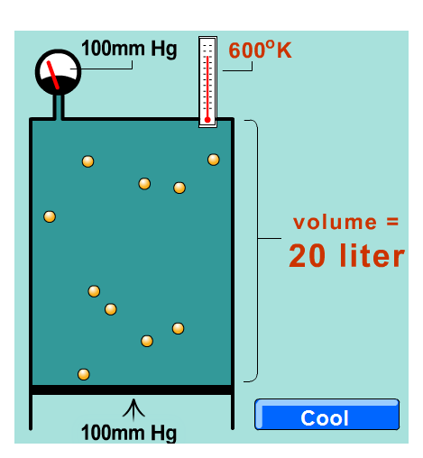

1.What 2 variables are held constant in this diagram?

2. What 2 variables are changing and what are their values?

3 What happened to the temperature and volume?

4. Use the KMT and particles to explain why the volume doubles when the temperature doubles at constant pressure and mass?

**The KMT states that all matter is constantly moving and as temperature is doubled the the average kinetic energy of the particles is doubled. The particles are then moving twice as fast. The volume must double to allow the same number of particles to move twice the distance and still maintain the same number of collisions against the walls (constant pressure).**

**Gay-Lussac’s Law**

**Sample Data - Is the data directly or inversely proportional?**

|  |  |  |  |
| --- | --- | --- | --- |
| Temperature (K) | Pressure (torr) | P * T = k | P/T = k |
| 186.5 | 520.3 |  |  |
| 248 | 691.6 |  |  |
| 273 | 758.9 |  |  |
| 373 | 1041.2 |  |  |

**avg.**

**Conclusion:**

**3 Characteristics of Directly Proportional Data**

1. Graph of data produces a straight line.

2. P/ T = k (constant)

3. As Temperature doubles, Pressure doubles and vice versa

Summary Gay-Lussac’s Law

Gay-Lussac’s Law - The pressure and absolute temperature (K) of a gas are directly related at constant mass & volume

P/ T = k (constant) or 

Examine the diagrams and answer the questions.

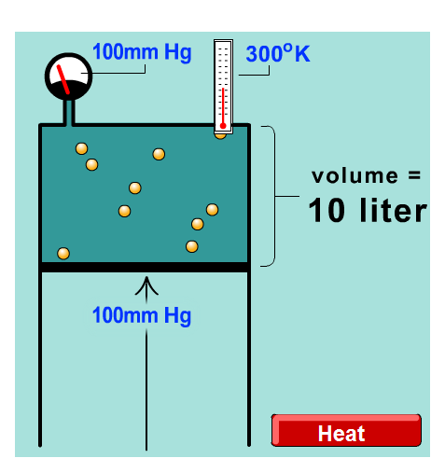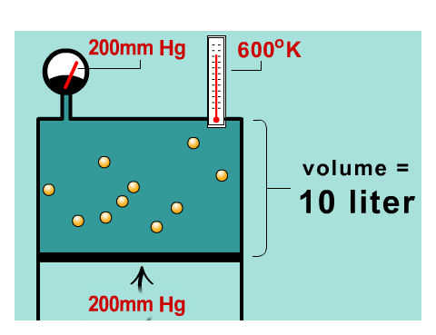

1. What 2 variables are held constant in this diagram?

2. What 2 variables are changing and what are their values?

3. What happened to the temperature and Pressure?

4. Use the KMT and particles to explain why the pressure doubles when the temperature doubles at constant volume and mass?

**The KMT states that all matter is constantly moving and as temperature is doubled the the average kinetic energy of the particles is doubled. The same number of particles are then moving twice as fast. At constant volume the particles will strike the walls twice as often doubling the pressure.**

How to remember which law goes with each variable:

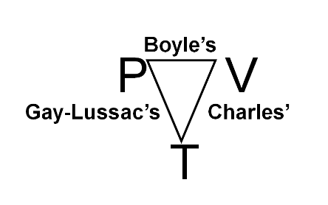

Combined Gas Law - Derived

If PV = k, and P/T = k and V/T = k then: PV/T = k



Rearranged combined gas law

**P1V1T2 = P2V2T1**

**Gas Law Handout**

Use this to help remember which variable goes with each gas law.



|  |  |  |
| --- | --- | --- |
| **Name** | **Gas Law Formula** | **Proportionality** |
| Boyle’s Law | P1V1 = P2V2 | Inverse,  **↑ Volume, ↓ Pressure**  **↓ Volume, ↑ Pressure** |
| Charles’s Law | V1/T1 = V2/T2 | Direct  **↑ Temp, ↑ Volume**  **↓ Temp, ↓ Volume** |
| Gay-Lussac’s Law | P1/T1 = P2/T2 | Direct  **↑ Temp, ↑ Pressure**  **↓ Temp, ↓ Pressure** |
| Combined Gas Law | P1V1/T1 = P2V2/T2 |  |
| Rearranged Combined Gas Law | P1V1T2 = P2V2T1 |  |

P1 = the initial pressure of the gas P2 = the final pressure of the gas

V1 = the initial volume of the gas V2 = the final volume of the gas

T1 = the initial temperature of the gas T2 = the final temperature of the gas

Here are some simple rules you should follow when using the gas law:

1) Always use **Kelvins** as your unit of temperature. If you use degrees Celsius, your answer will be wrong. (Incidentally, this rule goes for all gas law problems, no matter what equation you use).

2) Make sure that all variables with a subscript of “1” stand for the property of a gas before it has undergone a change in pressure, temperature, or volume. Make sure all variables with a subscript of “2” correspond to the properties of a gas after it has undergone a change. For example, if a gas was initially at a temperature of 500 K and the temperature was increased to 750 K, T1 is “500 K” and T2 is “750 K”.

**Quickly solve for a variable**

**Solve for T1 Solve for V2 Solve for V1**

P1V1T2 = P2V2T1 P1V1T2 = P2V2T1 P1V1T2 = P2V2T1

**The Gas Laws Examples – Ch. 10** (p.313-322)

Directions: Carefully read each gas law problem. Identify the given variables and unknown variable in the space provided. Identify the gas law and formula needed to solve the problem. Make a prediction about what will happen to the unknown variable. Justify, the prediction by calculating the predicated outcome. Answers should have units and correct number of significant figures.

1. A gas occupies 100. mL at 150. kPa. Find its volume at 200. kPa.

|  |  |  |
| --- | --- | --- |
| **given** | **gas law** | **Prediction and calculation** |
|  |  |  |
| **formula** |
| P1V1T2=P2V2T1 |

1. A gas occupies 473 mL at -36°C. Find its volume at 94°C.

|  |  |  |
| --- | --- | --- |
| **given** | **gas law** | **Prediction and calculation** |
|  |  |  |
| **formula** |
| P1V1T2=P2V2T1 |

1. A gas’ pressure is 765 torr at 23°C. At what temperature will the pressure be 560. torr?

|  |  |  |
| --- | --- | --- |
| **given** | **gas law** | **Prediction and calculation** |
|  |  |  |
| **formula** |
| P1V1T2=P2V2T1 |

1. A gas occupies 8 mL at 71.8 kPa & 25°C. Find its volume at STP.

|  |  |  |
| --- | --- | --- |
| **given** | **gas law** | **Prediction and calculation** |
|  |  |  |
| **formula** |
| P1V1T2=P2V2T1 |

**The Gas Laws – Ch. 10** (p.313-322)

Directions: Carefully read each gas law problem. Identify the given variables and unknown variable in the space provided. Identify the gas law and formula needed to solve the problem. Make a prediction about what will happen to the unknown variable. Justify, the prediction by calculating the predicated outcome. Answers should have units and correct number of significant figures.

1. The gas left in a used aerosol can is at a pressure of 1.0 atm at 27°C. If this can is thrown into a fire, what is the internal pressure of the gas when its temperature reaches 927°C?

|  |  |  |
| --- | --- | --- |
| given | gas law | Prediction and calculation |
|  |  |  |
| formula |
| P1V1T2=P2V2T1 |

1. A sample of carbon dioxide occupies a volume of 3.50 L at 125 kPa. What pressure would the gas exert if the volume were decreased to 2.00 L?

|  |  |  |
| --- | --- | --- |
| given | gas law | Prediction and calculation |
|  |  |  |
| formula |
|  |

1. A sample of propane occupies 250.0 L at 300 mm Hg and 38°C. Find its volume at 500. mm Hg and 95°C.

|  |  |  |
| --- | --- | --- |
| given | gas law | Prediction and calculation |
|  |  |  |
| formula |
| P1V1T2=P2V2T1 |

1. Oxygen gas is at a temperature of 40°C when it occupies a volume of 2.3 L. To what temperature **in Kelvins** should it be raised to occupy a volume of 6.5 L?

|  |  |  |
| --- | --- | --- |
| given | gas law | Prediction and calculation |
|  |  |  |
| formula |
|  |

1. Fluorine exerts a pressure of 900. torr. When the pressure is changed to 1140 torr, its volume is 250. mL. What was the original volume?

|  |  |  |
| --- | --- | --- |
| given | gas law | Prediction and calculation |
|  |  |  |
| formula |
| P1V1T2=P2V2T1 |

1. The volume of a gas is 200.0 mL at 275 K and 92.1 kPa. Find its volume at STP.

|  |  |  |
| --- | --- | --- |
| given | gas law | Prediction and calculation |
|  |  |  |
| formula |
| P1V1T2=P2V2T1 |

7. A sample of N2 occupies a volume of 250 mL at 25°C. What volume will it occupy at 95°C?

|  |  |  |
| --- | --- | --- |
| given | gas law | Prediction and calculation |
|  |  |  |
| formula |
| P1V1T2=P2V2T1 |

answer key pg 11-12 1. G.L. 4.0atm (2sf), 2. boyles 219 K (3sf), 3. combined 31 L (2sf), 4. Charles, 880 K (2sf), 5. Boyles 317 mL (3sf), 6 combined 180 mL (3sf), 7 Charles 310 mL (2 sf)

**Name:____________________ Date:________ Block:______**

**Combined Gas Law Problems**

*Use the combined gas law to solve the following problems:*

1) If I initially have a gas at a pressure of 12 atm, a volume of 23 liters, and a temperature of 200 K, and then I raise the pressure to 14 atm and increase the temperature to 300 K, what is the new volume of the gas?

|  |  |  |
| --- | --- | --- |
| Given | Gas Law | calculation |
|  |  |  |
| Formula |
| P1V1T2=P2V2T1 |

2. A sample of carbon dioxide occupies a volume of 3.50 L at 125 kPa. What pressure would the gas exert if the volume were decreased to 2.00 L?

|  |  |  |
| --- | --- | --- |
| Given | Gas Law | calculation |
|  |  |  |
| Formula |
| P1V1T2=P2V2T1 |

3) A gas takes up a volume of 17 liters, has a pressure of 2.3 atm, and a temperature of 299 K. If I raise the temperature to 350 K and lower the pressure to 1.5 atm, what is the new volume of the gas?

|  |  |  |
| --- | --- | --- |
| Given | Gas Law | calculation |
|  |  |  |
| Formula |
| P1V1T2=P2V2T1 |

4) A gas that has a volume of 28 liters, a temperature of 45 0C, and an unknown pressure has its volume increased to 34 liters and its temperature decreased to 35 0C. If I measure the pressure after the change to be 2.0 atm, what was the original pressure of the gas?

|  |  |  |
| --- | --- | --- |
| Given | Gas Law | calculation |
|  |  |  |
| Formula |
| P1V1T2=P2V2T1 |

5) A gas has a temperature of 14 0C, and a volume of 4.5 liters. If the temperature is raised to 29 0C and the pressure is not changed, what is the new volume of the gas?

|  |  |  |
| --- | --- | --- |
| Given | Gas Law | calculation |
|  |  |  |
| Formula |
| P1V1T2=P2V2T1 |

6) If I have 17 liters of gas at a temperature of 67 0C and a pressure of 88.89 atm, what will be the pressure of the gas if I raise the temperature to 94 0C and decrease the volume to 12 liters?

|  |  |  |
| --- | --- | --- |
| Given | Gas Law | calculation |
|  |  |  |
| Formula |
| P1V1T2=P2V2T1 |

7) I have an unknown volume of gas at a pressure of 0.5 atm and a temperature of 325 K. If I raise the pressure to 1.2 atm, decrease the temperature to 320 K, and measure the final volume to be 48 liters, what was the initial volume of the gas?

|  |  |  |
| --- | --- | --- |
| Given | Gas Law | calculation |
|  |  |  |
| Formula |
| P1V1T2=P2V2T1 |

8) If I have 21 liters of gas held at a pressure of 78 atm and a temperature of 900 K, what will be the volume of the gas if I decrease the pressure to 45 atm and decrease the temperature to 750 K?

|  |  |  |
| --- | --- | --- |
| Given | Gas Law | calculation |
|  |  |  |
| Formula |
| P1V1T2=P2V2T1 |

**answer key page 13-14. 1. combined, 30 L (1sf), 2. Boyles, 219 kPa (3sf), 3. combined 31 L (2sf), 4. combined, 2.5 atm (2sf), 5. Charles, 4.7 L (2sf), 6. combined, 140 L (2sf), 7. combined 100 L (1 sf), #8 combined, 30 L (2sf)**

Gas Laws Worksheet

#1 Examine the two pistons containing a gas below and answer the questions.

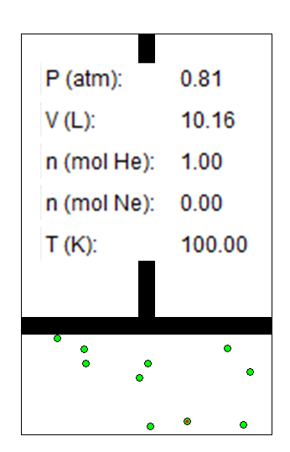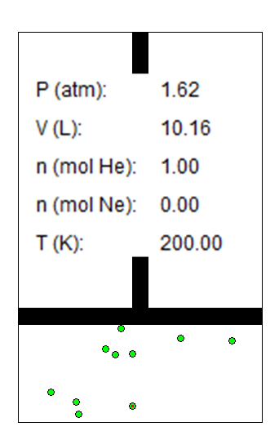

1. What 2 variables are held constant in this diagram?

2. What 2 variables are changing and what are their values?

3. What happened to the temperature and Pressure?

**4.** What gas is the name and formula for the gas law demonstrated by these diagrams?

5. Use the KMT and particles to explain why the pressure doubles when the temperature doubles at constant volume and mass?

# 2 Examine the two pistons containing a gas below and answer the questions.

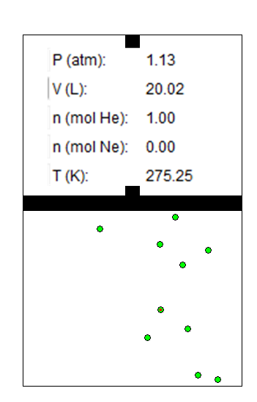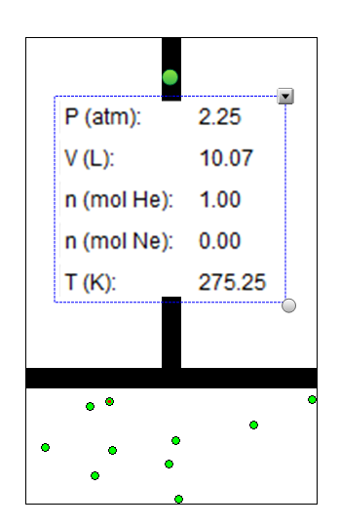

1. What 2 variables are held constant in these diagrams

2. What 2 variables are changing and what are their values?

3. What happened to the pressure and volume?

**4.** What gas is the name and formula for the gas law demonstrated by these diagrams?

5. Use the KMT and particles to explain why the pressure doubles when the volume is halved at constant temperature and mass?

# 3 Examine the two pistons containing a gas below and answer the questions.

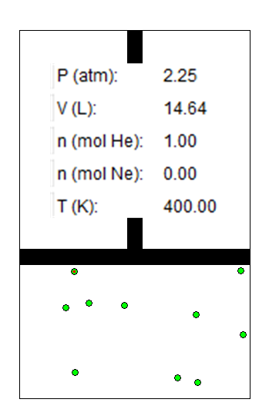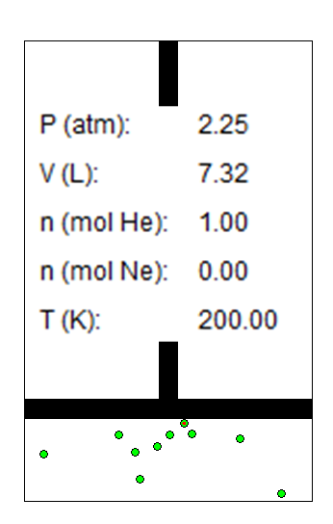

1.What 2 variables are held constant in this diagram?

2. What 2 variables are changing and what are their values?

3 What happened to the temperature and volume?

**4.** What gas is the name and formula for the gas law demonstrated by these diagrams?

5. Use the KMT and particles to explain why the volume doubles when the temperature doubles at constant pressure and mass?