**LOAN SUMMARY**

**CSi WARRANTED TRANSACTION**

**BASIC INFORMATION**

**Time Stamp:**

**13:03:38 Thursday, May 4, 2023**

Type of Loan:

Status:

Principal Amount:

Term:

Application

15,000.00

Secured:

Yes

Closing State:

PA

Proceeds Use:

Refinance Pledged Collateral with Cash out used for Home Improvement

Number of Borrowers:

Number of Cosigners:

Number of Guaranties:

Number of Hypothecations:

Number of Units of Collateral:

1

None

None

1 None

1

Has the Lender elected to use the stand-alone Consumer Security Agreement in the loan transaction as the security

instrument?

Will a revised Loan Estimate be reissued to the borrower?

No

No

Will the Intent To Proceed document be used to record the consumer's intent to proceed with the mortgage transaction? No

Do you want to generate a separate document to acknowledge receipt of the homeownership counselor list you have

provided?

Yes

Has the applicant entered into a lock-in agreement with the mortgage lender or mortgage broker?

Is the applicant waiving the appraisal copy delivery timing requirement?

Is this loan subject to the Farm Credit Act of 1971?

Do you want to collect government monitoring information on a standalone document?

Is this loan subject to the TILA-RESPA rule, which was effective as of October 3, 2015?

Will you supply the data necessary to complete the list of Homeownership Counseling Organizations?

Do you offer or solicit credit insurance?

Are you referring the borrower to an affiliated settlement service provider?

Will electronic signatures be used in the transaction?

Do you want to generate an amortization schedule?

No

Yes

No

No

Yes

No

No

No

No

No

No

Is this a high-cost loan subject to Regulation Z?

**Collateral: main_collateral**

Collateral Type:

State:

Real Estate (non-purchase money)

PA

Owner:

CONTACT_8

MARISOL TESTCASE (0)

No

Subordinate Lien Holder:

**Borrower: MARISOL TESTCASE (0)**

Entity Type:

Individual

PA

Yes

Residence State or Location:

Secured:

Is the borrower providing collateral to secure the loan?

Do you want to verify the taxpayer's tax returns?

Is a credit score being utilized to evaluate the applicant?

Yes

No

Yes

**Hypothecation: CONTACT_8**

Entity Type:

Residence State or Location:

Individual

PA

Do you want to verify the taxpayer's tax returns?

No

**APPLICATION DOCUMENTS**

Privacy Policy (DG9012 PrivacyPolicy.FXL)

Disclosure Of Homeowner Counseling Organizations (DL2272 DisclosureOfHomeownerCounselingOrganizations.FXL)

Loan Estimate (DL2302 LoanEstimate.FXL)

Document Selection Logic and Loan Summary (DL6000 Lending.FXL)

Notice Of Right To Copy Of Appraisal Report (DL6017 NoticeOfRightToCopyOfAppraisalReport.FXL)

**MARISOL TESTCASE (0)**

Notice To Home Loan Applicant And Credit Score Summary (DL2087

NoticeToHomeLoanApplicantAndCreditScoreSummary.FXL)

© 2006-2020 Compliance Systems, LLC e2350408-ceb2e695 - 2020.291.10.4

Document Selection Logic Loan Summary - DL6000

Page 1 of 2

www.compliancesystems.com

Borrowers Certification And Authorization (DL2101 BorrowersCertificationAndAuthorization.FXL)

Loan Application (DL2229 LoanApplication.FXL)

**Loan Summary Comments:**

REQUIRED LIST OF HOMEOWNERSHIP COUNSELING ORGANIZATIONS -- Institutions are required to provide a written list of

ten housing counseling agencies to applicants for all federally-related mortgages under Regulation X 1024.20. Your institution has

chosen not to use CSi's document to provide this disclosure. Institutions can visit

http://www.consumerfinance.gov/find-a-housing-counselor/ to generate and print the list of agencies in the applicant's area.

**CUSTOM SELECTION LOGIC**

File Name: Woodlands Bank_Global.txl

Data Set Name: Global

Description: 11/9/2020 8:13:50 PM

File Name: Woodlands Bank_Home Equity Preferred Rate.txl

Data Set Name: Home Equity Preferred Rate

Description: 8/25/2021 2:34:33 PM

File Name: Woodlands Bank_Consent to contact and Tax Returns.txl

Data Set Name: Consent to contact and Tax Returns

Description: 4/27/2021 7:03:24 PM

© 2006-2020 Compliance Systems, LLC e2350408-ceb2e695 - 2020.291.10.4

Document Selection Logic Loan Summary - DL6000

Page 2 of 2

www.compliancesystems.com

Rev. 08/18

**WHAT DOES WOODLANDS BANK DO WITH YOUR PERSONAL**

**INFORMATION?**

**FACTS**

**Why?**

Financial companies choose how they share your personal information. Federal law gives

consumers the right to limit some but not all sharing. Federal law also requires us to tell

you how we collect, share and protect your personal information. Please read this notice

carefully to understand what we do.

**What?**

The types of personal information we collect and share depend on the product or service

you have with us. This information can include:

**-** Social Security number and income

**-** Account balances and payment history

**-** Credit history and credit scores

When you are *no longer* our customer, we continue to share your information as

described in this notice.

**How?**

All financial companies need to share customers' personal information to run their

everyday business. In the section below, we list the reasons financial companies can

share their customers' personal information; the reasons Woodlands Bank chooses to

share; and whether you can limit this sharing.

**Does Woodlands Bank**

**share?**

**Can you limit this**

**sharing?**

**Reasons we can share your personal information**

**For our everyday business purposes--**

such as to process your transactions, maintain your

account(s), respond to court orders and legal

investigations, or report to credit bureaus

Yes

No

**For our marketing purposes--**

to offer our products and services to you

Yes

Yes

No

No

**For joint marketing with other financial**

**companies**

No

**For our affiliates' everyday business purposes--**

information about your transactions and experiences

We don't share

We don't share

We don't share

**For our affiliates' everyday business purposes--**

information about your creditworthiness

No

**For nonaffiliates to market to you**

No

**Questions?**

Call (570)327-5263 or go to www.woodlandsbank.com

© 1995-2020 Compliance Systems, LLC 157ffabd-a272d01d - 2020.241.0.2

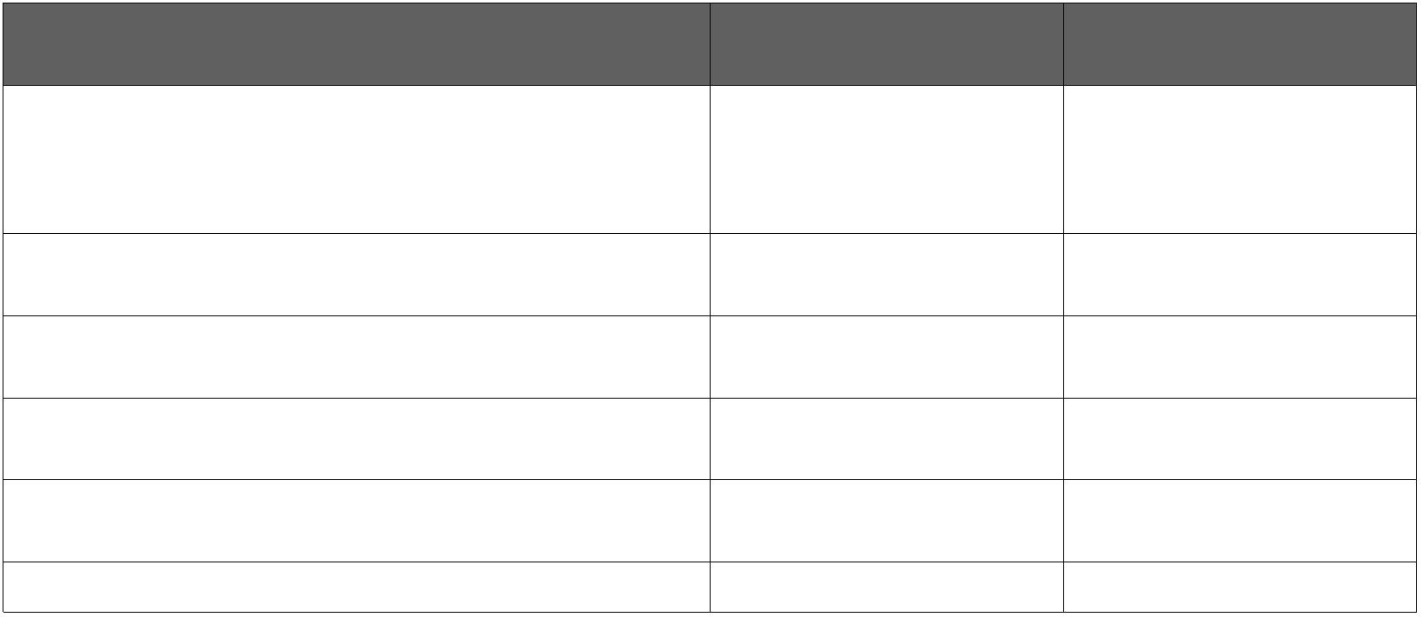

III**Page 2**

III**Who we are**

**Who is providing this notice?**

Woodlands Bank

**What we do**

**How does Woodlands Bank protect** To protect your personal information from unauthorized access and

**my personal information?**

use, we use security measures that comply with federal law. These

measures include computer safeguards and secured files and

buildings.

**How does Woodlands Bank collect** We collect your personal information, for example, when you

**my personal information?**

**-** Open an account or deposit money

**-** Pay your bills or apply for a loan

**-** Use your credit or debit card

We also collect your personal information from others, such as

credit bureaus, affiliates, or other companies.

**Why can't I limit all sharing?**

Federal law gives you the right to limit only

**-** sharing for affiliates' everyday business purposes - information

about your creditworthiness

**-** affiliates from using your information to market to you

**-** sharing for nonaffiliates to market to you

State laws and individual companies may give you additional rights

to limit sharing.

**Definitions**

**Affiliates**

Companies related by common ownership or control. They can be

financial and nonfinancial companies.

**-** *Woodlands Bank has no affiliates.*

**Nonaffiliates**

Companies not related by common ownership or control. They can

be financial and nonfinancial companies.

**-** *Woodlands Bank does not share with nonaffiliates so they can*

*market to you.*

**Joint marketing**

A formal agreement between nonaffiliated financial companies that

together market financial products or services to you.

**-** *Our joint marketing partner(s) include financial service providers*

*such as mortgage bankers, securities broker-dealers and Fintechs.*

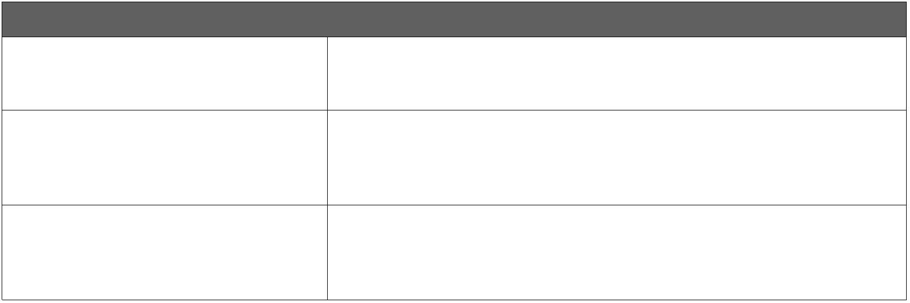

**NOTICE TO HOME LOAN APPLICANT AND CREDIT**

**SCORE SUMMARY**

**Woodlands Bank**

**2450 E Third St**

**Williamsport, Pennsylvania 17701**

**(570)327-5263**

**www.woodlandsbank.com**

**NMLS Company Identifier: 506857**

**NMLS Originator Identifier: 613876**

**APPLICATION NUMBER**

**APPLICATION DATE**

**CONSUMER REPORT DATE**

172000007

December 22, 2020

December 22, 2020

**APPLICANT INFORMATION**

MARISOL TESTCASE

521 N WASHINGTON ST

MONTOURSVILLE, PA 17754

**Credit Scores and the Price You Pay for Credit**

**Your Credit Score**

**Your credit score**

**Score:** 743

**Score:** 741

**Source:** Equifax

**Source:** Transunion

**Address:** PO Box 740241

Atlanta, GA 30374

**Address:** PO Box 2000

Chester, PA 19016

**Phone:** (800)685-1111

**Date:** December 22, 2020

**Phone:** (800)888-4213

**Date:** December 22, 2020

**Score:** 745

**Source:** Experian

**Address:** PO Box 2002

Allen, TX 75013

**Phone:** (888)397-3742

**Date:** December 22, 2020

**Understanding Your Credit Score**

**What you should know about**

**credit scores**

Your credit score is a number that reflects the information in your credit report.

Your credit report is a record of your credit history. It includes information about whether you pay your

bills on time and how much you owe to creditors.

Your credit score can change, depending on how your credit history changes.

**How we use your credit score**

**The range of scores**

Your credit score can affect whether you can get a loan and how much you will have to pay for that loan.

Equifax scores range from a low of **334** to a high of **818.** Transunion scores range from a low of **336** to a

high of **843.** Experian scores range from a low of **300** to a high of **850.**

Generally, the higher your score, the more likely you are to be offered better credit terms.

**How your score compares to**

**the scores of other consumers**

Your Equifax credit score ranks higher than 55 percent of U.S. Consumers. Your Transunion credit score

ranks higher than 54 percent of U.S. Consumers. Your Experian credit score ranks higher than 55 percent

of U.S. Consumers.

**Key factors that adversely**

**affected your credit score**

Equifax

Transunion

• TOO MANY INQUIRIES LAST 12 MONTHS

• LENGTH OF TIME REVOLVING

ACCOUNTS HAVE BEEN ESTABLISHED

• LENGTH OF TIME ACCOUNTS HAVE

BEEN ESTABLISHED

• TOO MANY INQUIRIES LAST 12 MONTHS

• LENGTH OF TIME REVOLVING

ACCOUNTS HAVE BEEN ESTABLISHED

• LENGTH OF TIME ACCOUNTS HAVE

BEEN ESTABLISHED

• TIME SINCE MOST RECENT ACCOUNT

OPENING IS TOO SHORT

• TIME SINCE MOST RECENT ACCOUNT

OPENING IS TOO SHORT

• INQUIRIES IMPACTED THE CREDIT

SCORE

© 2004-2020 Compliance Systems, LLC bf560bd5-55149fd5 - 2020.241.0.2

Notice To The Home Loan Applicant and Credit Score Summary - DL2087

Page 1 of 2

www.compliancesystems.com

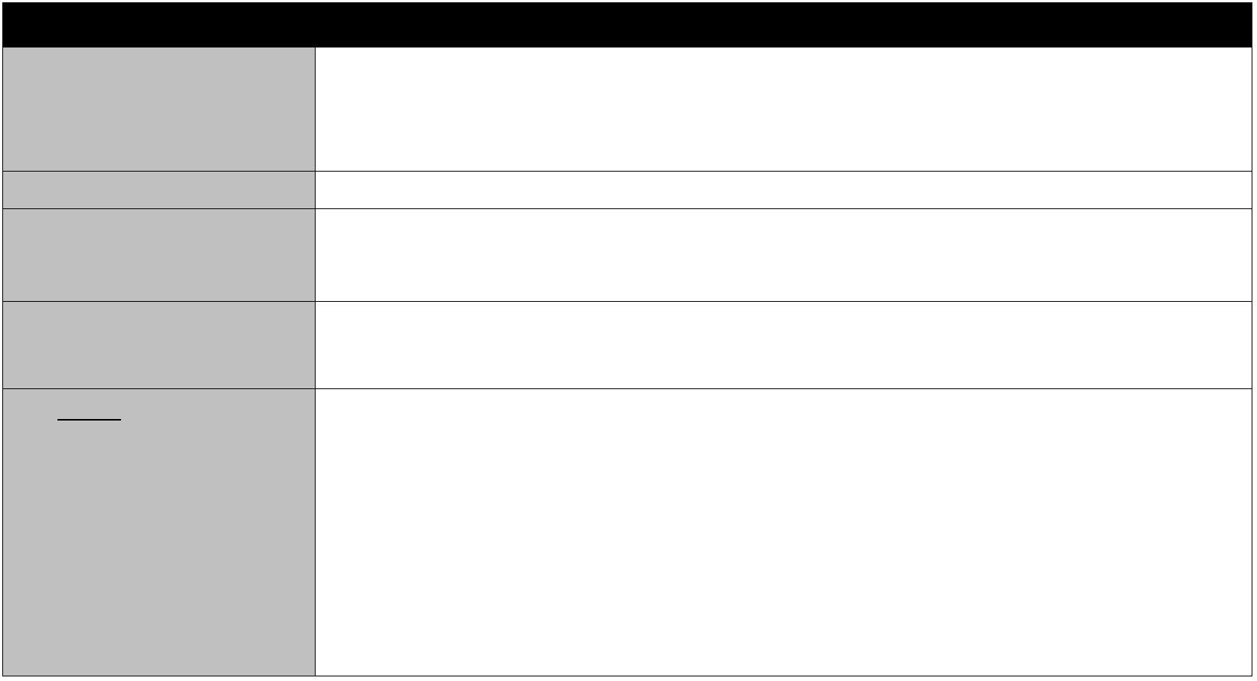

Experian

• TOO MANY INQUIRIES LAST 12 MONTHS

• TOO MANY ACCOUNTS RECENTLY

OPENED

• LENGTH OF TIME ACCOUNTS HAVE

BEEN ESTABLISHED

**Checking Your Credit Report**

**What if there are mistakes in**

**your Credit Report?**

You have a right to dispute any inaccurate information in your credit report. If you find mistakes on your

credit report, contact the consumer reporting agency.

It is a good idea to check your credit report to make sure the information it contains is accurate.

**How can you obtain a copy of**

**your credit report?**

Under federal law, you have the right to obtain a free copy of your credit report from each of the

nationwide consumer reporting agencies once a year.

To order your free annual credit report --

*By telephone:* Call toll-free: 1-877-322-8228

*On the web:*

*By mail:*

Visit www.annualcreditreport.com

Mail your completed Annual Credit Report Request Form (which you can obtain from

the Federal Trade Commission's web site at

http://www.ftc.gov/bcp/conline/include/requestformfinal.pdf) to:

Annual Credit Report Request Service

P.O. Box 105281

Atlanta, GA 30348-5281

**How can you get more**

**information?**

For more information about credit reports and your rights under Federal law, visit the Consumer Financial

Protection Bureau's web site at www.consumerfinance.gov/learnmore.

**NOTICE TO THE HOME LOAN APPLICANT**

In connection with your application for a home loan, the Lender must disclose to you the score that a consumer reporting agency distributed to

users and the Lender used in connection with your home loan, and the key factors affecting your credit scores.

The credit score is a computer generated summary calculated at the time of the request and based on information a consumer reporting agency or

Lender has on file. The scores are based on data about your credit history and payment patterns. Credit scores are important because they are

used to assist the Lender in determining whether you will obtain a loan. They may also be used to determine what interest rate you may be

offered on the mortgage. Credit scores can change over time, depending on your conduct, how your credit history and payment patterns change,

and how credit scoring technologies change.

Because the score is based on information in your credit history, it is very important that you review the credit-related information that is being

furnished to make sure it is accurate. Credit records may vary from one company to another.

If you have questions about your credit score or the credit information that is furnished to you, contact the consumer reporting agency at the

address and telephone number provided with this notice, or contact the Lender, if the Lender developed or generated the credit score. The

consumer reporting agency plays no part in the decisions to take any action on the loan application and is unable to provide you with specific

reasons for the decision on a loan application.

If you have questions concerning the terms of the loan, contact the lender.

MARISOL TESTCASE

Date

© 2004-2020 Compliance Systems, LLC bf560bd5-55149fd5 - 2020.241.0.2

Notice To The Home Loan Applicant and Credit Score Summary - DL2087

Page 2 of 2

www.compliancesystems.com

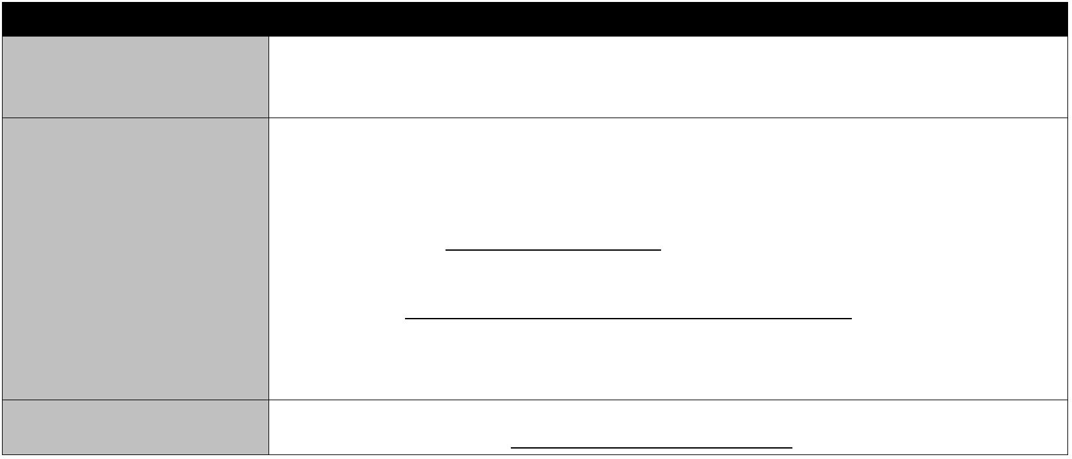

**BORROWER CERTIFICATION AND**

**AUTHORIZATION**

**Woodlands Bank**

**2450 E Third St**

**Williamsport, Pennsylvania 17701**

**(570)327-5263**

**www.woodlandsbank.com**

**NMLS Company Identifier: 506857**

**NMLS Originator Identifier: 613876**

**DATE**

December 22, 2020

**BORROWER INFORMATION**

MARISOL TESTCASE

521 N WASHINGTON ST

MONTOURSVILLE, PA 17754

**DEFINITIONS.** "Lender" means Woodlands Bank whose address is 2450 E Third St, Williamsport, Pennsylvania 17701 . "I" means each

person who signs this Borrower Certification and Authorization. "Your" means each entity receiving a copy of this Borrower Certification and

Authorization.

**CERTIFICATION**

The undersigned certify the following:

1. I have applied for a mortgage loan from Lender. In applying for the loan, I completed a loan application containing various information on

the purpose of the loan, the amount and source of the down payment, employment and income information, and assets and liabilities. I

certify that all of the information is true and complete. I made no misrepresentations in the loan application or other documents, nor did I

omit any pertinent information.

2. I understand and agree that Lender reserves the right to change the mortgage loan review process to a full documentation program. This may

include verifying the information provided on the application with the employer and/or the financial institution.

3. I fully understand that it is a Federal crime punishable by fine or imprisonment, or both, to knowingly make any false statements when

applying for this mortgage, as applicable under the provisions of Title 18, United States Code, Section 1014.

**AUTHORIZATION TO RELEASE INFORMATION**

To Whom It May Concern:

1. I have applied for a mortgage loan from Lender. As part of the application process, Lender may verify information contained in my loan

application and in other documents required in connection with the loan, either before the loan is closed or as part of its quality control

program.

2. I authorize you to provide to Lender and to any investor to whom Lender may sell my mortgage any and all information and documentation

that they request. Such information includes, but is not limited to, employment history and income; bank, money market, and similar

account balances; credit history; and copies of income tax returns.

3. Lender or any investor that purchases the mortgage may address this authorization to any party named in the loan application.

4. A copy of this authorization may be accepted as an original.

5. Your prompt reply to Lender or the investor that purchased the mortgage is appreciated.

**By signing this Borrower Certification and Authorization, Borrower acknowledges reading, understanding and agreeing to all its**

**provisions, and receiving a copy of it.**

MARISOL TESTCASE

Date

© 2007-2020 Compliance Systems, LLC de7561f9-16995c38 - 2020.291.6.4

Borrower Certification And Authorization - DL2101

Page 1 of 1

www.compliancesystems.com



**HOME EQUITY CONSUMER LOAN APPLICATION**

**Woodlands Bank**

**2450 E Third St**

**Williamsport, Pennsylvania 17701**

**(570)327-5263**

**www.woodlandsbank.com**

**Loan Originator Company Name: Woodlands Bank**

**NMLS Company Identifier: 506857**

**Loan Originator Name: Teresa Brown**

**NMLS Originator Identifier: 613876**

**APPLICATION NUMBER**

**DATE**

172000007

December 22, 2020

**APPLICANT INFORMATION**

MARISOL TESTCASE

521 N WASHINGTON ST

MONTOURSVILLE, PA 17754

**LENDER.** "Lender" means Woodlands Bank whose address is 2450 E Third St, Williamsport, Pennsylvania 17701.

**APPLICANT.** "Applicant," "you," or "your" means each person who signs this Home Equity Consumer Loan Application.

**IDENTITY VERIFICATION.** To help the government fight the funding of terrorism and money laundering activities, Federal law requires all

financial institutions to obtain, verify and record information that identifies each person who opens an account.

What this means for you: When you open an account, we will ask for your name, address, date of birth and other information that will allow us

to identify you. We may also ask to see your driver's license or other identifying documents.

**LOAN APPLICATION INFORMATION.**

•

•

You are applying for a closed-end home equity loan.

You are applying individually with your own income or assets.

**LOAN TERMS**

Loan Amount:

$15,000.00

Interest Rate:

4.250%

Loan Term (months):

60

Rate Type:

Fixed Rate

Payment Amount:

$277.95

**COLLATERAL INFORMATION AND PURPOSE OF LOAN**

Property Address: 521 N WASHINGTON ST, MONTOURSVILLE, Pennsylvania 17754

Purchase Price: $0

Insurance Carrier Name: FARMERS INSURANCE

Insurance Carrier Address:

123 WASHINGTON BLVD, WILLIAMSPORT, Pennsylvania 17701

Purpose of Loan: HOME IMPROVEMENT

**APPLICANT INFORMATION**

Applicant Name: MARISOL TESTCASE

Taxpayer ID Number:

000-00-0001

Date of Birth: 02/21/1962

Driver's License Number:

12121212

Phone Number: (570)368-4700

Business Phone Number: (570)

320-2496

Email Address:

WMILLER@WOODLANDSBANK.

COM

Marital Status: Unmarried (including single, divorced and widowed)

Immigration Status: U.S. citizen.

Additional Information:

**EMPLOYMENT INFORMATION**

Applicant Name: MARISOL TESTCASE

© 2009-2020 Compliance Systems, LLC 06625ec6-c642fa48 - 2020.241.0.2

Home Equity Consumer Loan Application - DL2229

Page 1 of 4

www.compliancesystems.com

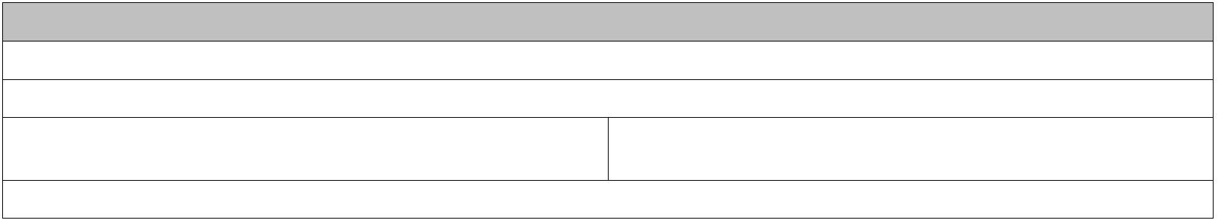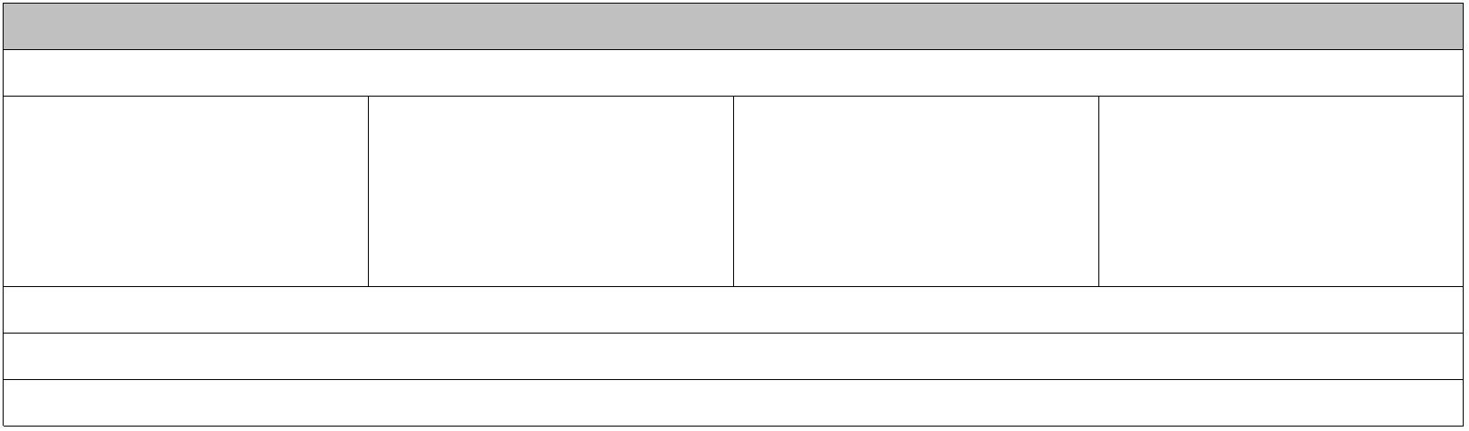

Name & Address of Current

Employer: WOODLANDS

BANK

Years on the job: 29

Years employed in this

line of work/profession: 29 Business: BANKER

Position/Title/Type of

Business Phone:

(570)320-2496

☐ Self Employed

**MONTHLY INCOME AND COMBINED HOUSING EXPENSE INFORMATION**

Applicant Name

Base Empl. Overtime Bonuses

Income*

Commissions

Dividends/ Net Rental Other (before

Total

Interest

Income

completing, see

"describe other

income" below)

MARISOL TESTCASE

Total

$5,000

$5,000

$0

$0

$0

$0

$0

$0

$0

$0

$0

$0

$0

$0

$5,000

$5,000

* Self-employed Applicant(s) may be required to provide additional documentation such as tax returns and financial statements.

**Describe Other Income**. *Notice:* Alimony, child support or separate maintenance income need not be revealed

if the Applicant does not choose to have it considered for repaying this loan.

Applicant Name

Monthly Amount

$

**Combined**

**Monthly Housing**

**Expense**

Rent

First Mortgage

(P&I)

Other

Financing

(P&I)

Hazard

Insurance

Real Estate

Taxes

Mortgage

Insurance

Homeowners

Assn. Dues

Other

Total

**Present**

$0.00

$0.00

**Proposed**

**ASSETS AND LIABILITIES**

This statement and any applicable supporting schedules may be completed jointly by both married and unmarried Applicant(s) if their assets

and liabilities are sufficiently joined so that the Statement can be meaningfully and fairly presented on a combined basis; otherwise, separate

Statements and Schedules are required. If the Applicant section was completed about a non-applicant spouse or other person, this Statement

and supporting schedules must be completed about that spouse or other person also.

Completed

☐ Jointly ☒ Not Jointly

**ASSETS**

**Cash or Market Liabilities and Pledged Assets.** List the creditor's name, address, and account

Description

**Value**

number for all outstanding debts, including automobile loans, revolving charge

accounts, real estate loans, alimony, child support, stock pledges, etc. Use

continuation sheet, if necessary. Indicate by (*) those liabilities, which will be

satisfied upon sale of real estate owned or upon refinancing of the subject property.

Liabilities marked (**) indicate values not included in the total.

Cash deposit toward purchase held

by:

$

0.00

***List* *checking* *and* *savings* *accounts* *below***

**LIABILITIES**

**Monthly Payment Unpaid Balance**

**& Months Left to**

**Pay**

Name and address of Bank, S & L, or Credit Union

WOODLANDS BANK

Name and address of Company

USAA FEDERAL SAVINGS B

PO BOX 47504, SAN ANTONIO, Texas

78265

$ Payment 533.00

/ 60 Months

$

28,626.00

Acct Owner: MARISOL TESTCASE

Acct Owner: MARISOL TESTCASE

Acct No. 21212110

$

2,000.00 Acct No. ACCT000006

Name and address of Bank, S & L, or Credit Union

MUNCY BANK

Name and address of Company

CHASE

$ Payment 10.00

/ Months

$

228.00

PO BOX 15369, WILMINGTON,

Delaware 19850

Acct Owner: MARISOL TESTCASE

Acct Owner: MARISOL TESTCASE

Acct No. 11210121

$

15,000.00 Acct No. ACCT000002

Stocks and Bonds (Company

name/number & Description)

$

© 2009-2020 Compliance Systems, LLC 06625ec6-c642fa48 - 2020.241.0.2

Home Equity Consumer Loan Application - DL2229

Page 2 of 4

www.compliancesystems.com

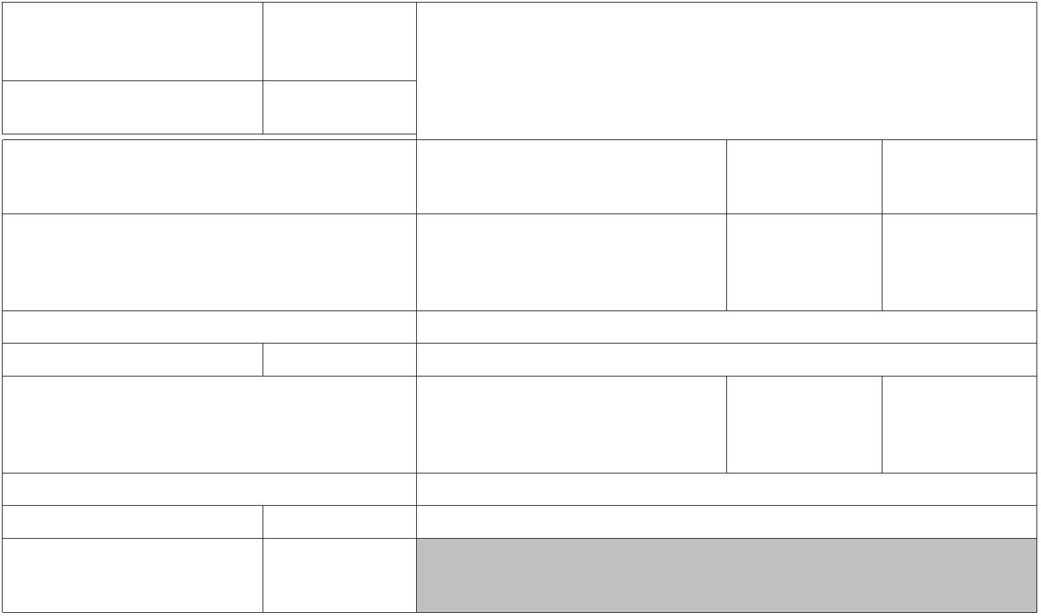

Life insurance net cash value

Face amount: $ 0

$

$

$

0.00

17,000.00

100,000.00

**Subtotal Liquid Assets**

Real Estate owned (enter market

value from schedule of real estate

owned)

Vested interest in retirement fund

$

$

0.00

0.00

Net worth of business(es) owned

(attach financial statement)

Automobiles owned (make and

year):

Alimony/Child Support/Separate

Maintenance Payments Owed to:

$

$

0.00

0.00

alimony

child support

Other Assets (itemize):

Job-Related Expense (child care, union

dues, etc.):

$

$

$

0.00

**Total Monthly Payments**

543.00

Net Worth

(a. minus b.)

**Total Assets a.** $

117,000.00

$

88,146.00 **Total Liabilities b.** $

28,854.00

**ACKNOWLEDGMENT.** You warrant the truth of the information contained in this application and that all statements made in this application

are made for the purpose of obtaining the loan applied for. You warrant that the financial obligations you disclosed in this application and in

support of this application are complete and that you have no other outstanding financial obligations of any kind, including any guarantor or

cosigner liability. Lender, its agents, successors, and assigns, will rely on the information contained in this application, and you have a

continuing obligation to amend and supplement the information provided in this application if any of the material facts you represented should

change before closing. If you have left any spaces in this application blank, Lender, its agents, successors, and assigns, may assume the

information requested is adverse. Each of the undersigned hereby acknowledges that any owner of the Loan, its servicers, successors and

assigns, may verify or reverify any information contained in this application or obtain any information or data relating to the Loan, for any

legitimate business purpose through any source, including a source named in this application or a consumer reporting agency. You understand

that it is your sole and exclusive responsibility to determine all the tax effects of the loan and acknowledge that Lender, its agents, successors,

and assigns, have not provided any tax advice to you. Lender, its agents, successors, and assigns, can give information about your loan to credit

reporting agencies and others who may properly receive that information. If Lender approves this application and Lender, its agents, successors,

and assigns, are required to report the amount of interest paid on the loan to the Internal Revenue Service, you understand that Lender, its agents,

successors, and assigns, will report using the Social Security Number (tax identification number) shown above. You understand that if the Social

Security Number is incorrect, that you may be subject to Internal Revenue Service penalties. You understand Lender, its agents, successors, and

assigns, will keep this application whether or not my credit request is approved.

In this regard, a credit report may be requested in connection with this application.

**Certification.** You certify that the information provided in this application is true and correct as of the date set forth opposite my signature on

this application and acknowledge my understanding that any intentional or negligent misrepresentations of the information contained in this

application may result in civil liability and/or criminal penalties including, but not limited to, fine or imprisonment or both under the provisions

of Title 18, United States Code, Section 1001, et seq., and liability for monetary damages to the Lender, its agents, successors, assigns, insurers,

and any other person who may suffer any loss due to reliance upon any misrepresentation you made in this application or in any other manner.

**By signing this Home Equity Consumer Loan Application, the Applicant acknowledges reading, understanding and agreeing to all its**

**provisions, and receiving a copy of it.**

MARISOL TESTCASE

Date

**DEMOGRAPHIC INFORMATION OF APPLICANT**

**The purpose of collecting this information** is to help ensure that all applicants are treated fairly and that the housing needs of communities and

neighborhoods are being fulfilled. For residential mortgage lending, Federal law requires that we ask applicants for their demographic information

(ethnicity, sex, and race) in order to monitor our compliance with equal credit opportunity, fair housing, and home mortgage disclosure laws. You are

not required to provide this information, but are encouraged to do so. You may select one or more designations for "Ethnicity" and one or more

designations for "Race." **The law provides that we may not discriminate** on the basis of this information, or on whether you choose to provide it.

However, if you choose not to provide the information and you have made this application in person, Federal regulations require us to note your

© 2009-2020 Compliance Systems, LLC 06625ec6-c642fa48 - 2020.241.0.2

Home Equity Consumer Loan Application - DL2229

Page 3 of 4

www.compliancesystems.com

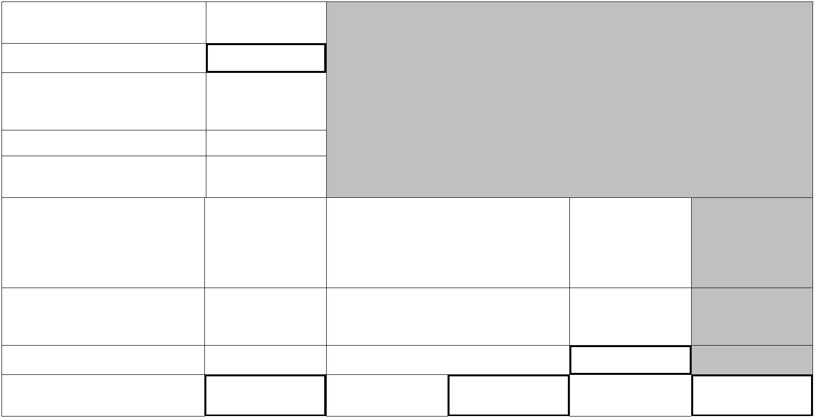

ethnicity, sex, and race on the basis of visual observation or surname. The law also provides that we may not discriminate on the basis of age or marital

status information you provide in this application. If you do not wish to provide some or all of this information, please check below.

**Ethnicity** *Check one or more*

☐ Hispanic or Latino

**Race** *Check one or more*

☐ American Indian or Alaska Native - *Print name of enrolled*

☐ Mexican

☐ Puerto Rican

☐ Cuban

*or principal tribe:*

☐ Other Hispanic or Latino - *Print origin:*

☐ Asian

☐ Asian Indian

☐ Japanese

☐ Other Asian - *Print race:*

☐ Chinese

☐ Korean

☐ Filipino

☐ Vietnamese

*For example: Argentinean, Colombian, Dominican, Nicaraguan,*

*Salvadoran, Spaniard, and so on.*

☒ Not Hispanic or Latino

*For example: Hmong, Laotian, Thai, Pakistani, Cambodian, and so on.*

☐ Black or African American

☐ I do not wish to provide this information

☐ Native Hawaiian or Other Pacific Islander

**Sex**

☐ Native Hawaiian

☐ Guamanian or Chamorro

☐ Samoan

☒ Female

☐ Other Pacific Islander - *Print race:*

☐ Male

☐ I do not wish to provide this information

*For example: Fijian, Tongan, and so on.*

☒ White

☐ I do not wish to provide this information

**To Be Completed by Financial Institution (*for* *application* *taken* *in* *person*):**

Was the ethnicity of the Borrower collected on the basis of visual observation or surname?

Was the race of the Borrower collected on the basis of visual observation or surname?

Was the sex of the Borrower collected on the basis of visual observation or surname?

NO

NO

NO

YES

YES

YES

**The Demographic Information was provided through:**

☒ Face-to-Face Interview *(includes Electronic Media w/Video Component)*

☐ Telephone Interview

☐ Fax or Mail ☐ Email or Internet

**CREDITOR USE ONLY**

Interest (fixed/variable):

Method Application Taken By:

☒ In a face-to-face interview

☐ In a telephone interview

☐ By the applicant and submitted by fax or mail

☐ By the applicant and submitted via e-mail or the Internet

Floor Rate:

Date Application Received:

Ceiling Rate:

Received By:

Teresa Brown

Interest Adjustments:

Index:

Date Application Completed:

Approved By:

Payment Frequency:

First Payment Date:

Billing Method:

Credit Insurance:

Initial Advance:

Reasons for Denial:

Amount Requested:

Amount Approved:

Rescindable (yes/no):

RESPA Transaction (yes/no):

Funding Date:

Loan Approval Conditions:

Customer Identification Program (CIP) Record Information:

Information Collected and Verified in Accordance With CIP (initial) ________

© 2009-2020 Compliance Systems, LLC 06625ec6-c642fa48 - 2020.241.0.2

Home Equity Consumer Loan Application - DL2229

Page 4 of 4

www.compliancesystems.com

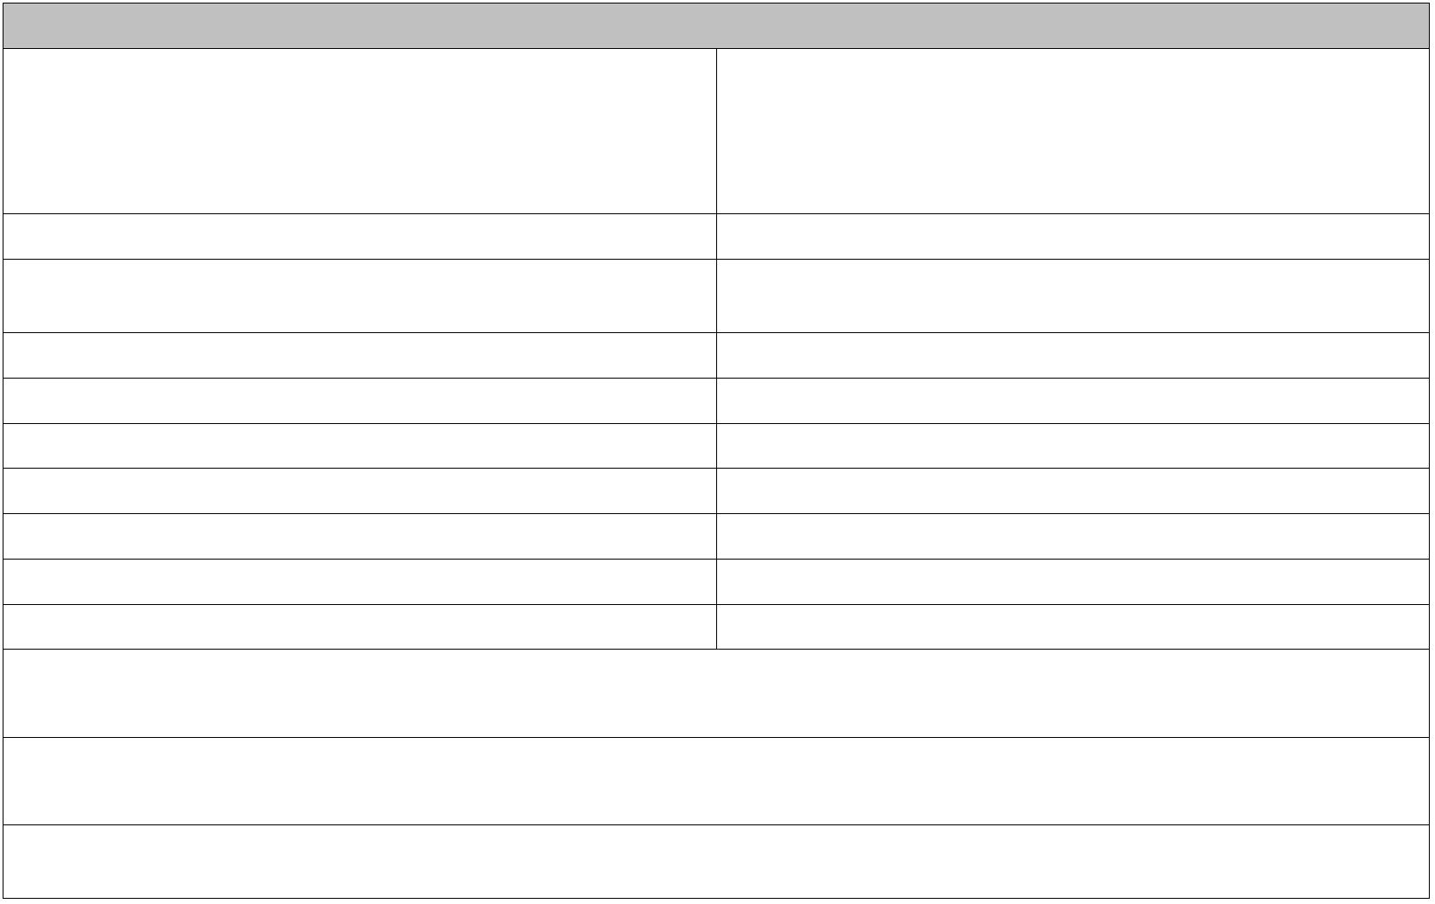

**ACKNOWLEDGMENT OF RECEIPT OF**

**HOMEOWNERSHIP COUNSELING ORGANIZATIONS 2450 E Third St**

**Williamsport, Pennsylvania 17701**

**Woodlands Bank**

**DISCLOSURE**

**(570)327-5263**

**www.woodlandsbank.com**

**LOAN NUMBER**

**APPLICATION DATE**

172000007

December 22, 2020

**APPLICANT INFORMATION**

MARISOL TESTCASE

521 N WASHINGTON ST

MONTOURSVILLE, PA 17754

**ACKNOWLEDGMENT OF RECEIPT OF HOMEOWNERSHIP COUNSELING ORGANIZATIONS DISCLOSURE**

In connection with my mortgage loan application, I received a written list of at least ten HUD-approved homeownership counseling

organizations in my area that included details about the counseling services offered, counselor contact information, and disclosure of CFPB and

HUD resources for identifying other counseling agencies.

**By signing below, I acknowledge receiving a copy of, reading, and understanding the written list of homeownership counseling**

**organizations described above.**

MARISOL TESTCASE

Date

© 2013-2020 Compliance Systems, LLC 4805f708-cb530816 - 2020.290.0.2

Acknowledgment of Receipt of Homeownership Counseling Organizations Disclosure -

DL2272

Page 1 of 1

www.compliancesystems.com



WOODLANDS BANK

2450 E Third St • Williamsport, PA 17701

Save this Loan Estimate to compare with your Closing Disclosure.

**Loan Estimate**

**LOAN TERM** 5 years

**PURPOSE**

Home Equity Loan

Fixed Rate

**DATE ISSUED** 12/22/2020

**APPLICANTS** MARISOL TESTCASE

521 N WASHINGTON ST

**PRODUCT**

**LOAN TYPE**

**LOAN ID#**

**RATE LOCK**

☒

Conventional

☐

FHA

☐

VA

☐

________________

172000007

NO

MONTOURSVILLE, PA 17754

YES, until

☒

☐

**PROPERTY**

521 N WASHINGTON ST

MONTOURSVILLE, PA 17754

$100,000.00

Before closing, your interest rate, points, and lender credits can

change unless you lock the interest rate. All other estimated

closing costs expire on **1/7/2021** at 6:00 p.m. EST

**EST. PROP.**

**VALUE**

**Loan Terms**

**Loan Amount**

**Can this amount increase after closing?**

$15,000

4.25%

**NO**

**NO**

**NO**

**Interest Rate**

$277.95

**Monthly Principal & Interest**

See Projected Payments below for your

Estimated Total Monthly Payment

**Does the loan have these features?**

**NO**

**Prepayment Penalty**

**Balloon Payment**

**NO**

**Projected Payments**

**Payment Calculation**

**Years 1 - 5**

Principal & Interest

Mortgage Insurance

Estimated Escrow

$277.95

+ 0

+ 0

Amount can increase over time

**Estimated Total**

$277.95

**Monthly Payment**

**This estimate includes**

**In escrow?**

**NO**

☒ Property Taxes

**Estimated Taxes, Insurance**

$250

a month

☒ Homeowner's Insurance

**NO**

**& Assessments**

Other:

Amount can increase over time

☐

See Section G on page 2 for escrowed property costs. You must pay for

other property costs separately.

**Costs at Closing**

$0

Includes $85 in Loan Costs + $93 in Other Costs – $178 in Lender

Credits. See page 2 for details.

**Estimated Closing Costs**

$15,000

Includes Closing Costs.

☐ From ☒ To Borrower

**Estimated Cash to Close**

See Calculating Cash to Close on page 2 for details.

Visit **www.consumerfinance.gov/mortgage-estimate** for general information and tools.

LOAN ESTIMATE

© 2016-2020 Compliance Systems, LLC ea59350f-a76e0e00 - 2020.291.8.2

PAGE 1 OF 3 • LOAN ID # 172000007

DL2302 - www.compliancesystems.com

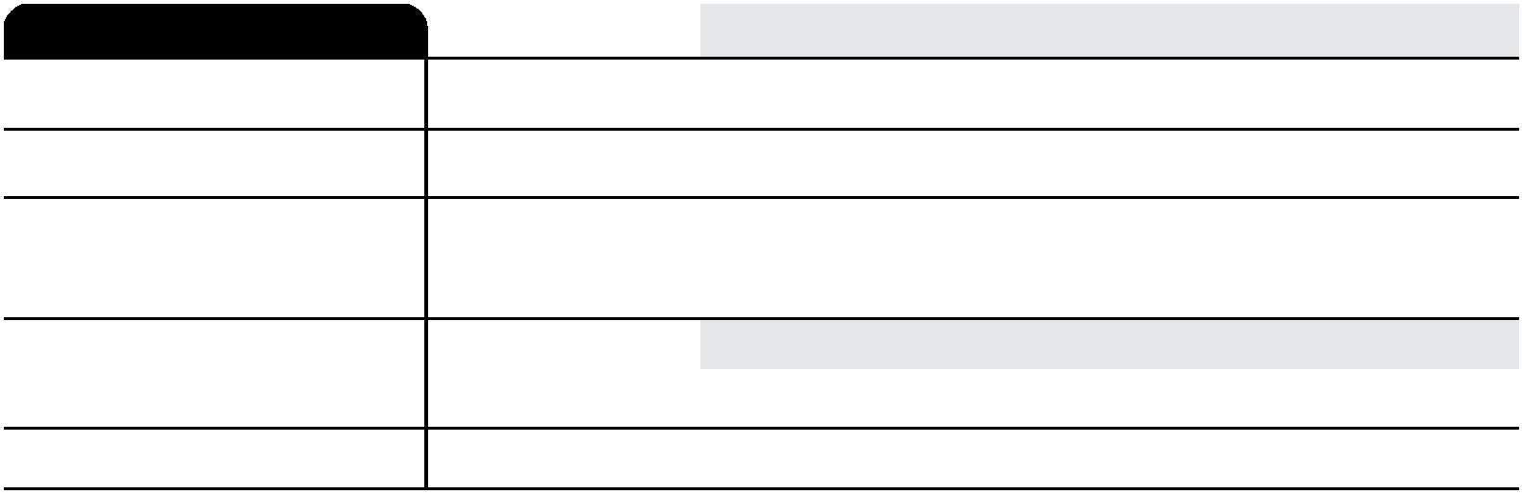

**Closing Cost Details**

**Loan Costs**

**Other Costs**

**A. Origination Charges**

**E. Taxes and Other Government Fees**

**$93**

0% of Loan Amount (Points)

Recording Fees and Other Taxes

Transfer Taxes

$93

**F. Prepaids**

Homeowner's Insurance Premium (

Mortgage Insurance Premium (

months)

months)

days @

Prepaid Interest (

per day for

)

Property Taxes (

months)

**G. Initial Escrow Payment at Closing**

Homeowner's Insurance

Mortgage Insurance

Property Taxes

per month for

per month for

per month for

mo.

mo.

mo.

**B. Services You Cannot Shop For**

**$85**

AVM Property Report Fee

Flood Determination Fee

Flood Life of Loan Monitoring Fee

Lycoming County Title Search

Single Credit Report

$15

$10

$2

$50

$8

**H. Other**

**I. TOTAL OTHER COSTS (E + F + G + H)**

**J. TOTAL CLOSING COSTS**

**$93**

**$0**

**C. Services You Can Shop For**

D + I

$0

Lender Credits

– $178

**Calculating Cash to Close**

Loan Amount

$15,000

$0

Total Closing Costs ( J)

Estimated Total Payoffs and Payments

**Estimated Cash to Close** ☐ **From** ☒ **To Borrower**

$0

$15,000

Estimated Closing Costs Financed

(Paid from your Loan Amount)

$0

**D. TOTAL LOAN COSTS (A + B + C)**

**$85**

LOAN ESTIMATE

© 2016-2020 Compliance Systems, LLC ea59350f-a76e0e00 - 2020.291.8.2

PAGE 2 OF 3 • LOAN ID # 172000007

DL2302 - www.compliancesystems.com



**Additional Information About This Loan**

**LENDER**

Woodlands Bank

506857

Teresa Brown

613876

tbrown@woodlandsbank.com

(570)320-2495

**MORTGAGE BROKER**

**NMLS ID/__ LICENSE ID**

**LOAN OFFICER**

**NMLS ID/__ LICENSE ID**

**EMAIL**

**NMLS ID/__ LICENSE ID**

**LOAN OFFICER**

**NMLS ID/__ LICENSE ID**

**EMAIL**

**PHONE**

**PHONE**

**Comparisons**

**Use these measures to compare this loan with other loans.**

$16,762

$15,000

Total you will have paid in principal, interest, mortgage insurance, and

loan costs.

Principal you will have paid off.

**In 5 Years**

Your costs over the loan term expressed as a rate. This is not your

interest rate.

4.256%

**Annual Percentage Rate (APR)**

**Total Interest Percentage (TIP)**

The total amount of interest that you will pay over the loan term as a

percentage of your loan amount.

11.179%

**Other Considerations**

**Appraisal**

We may order an appraisal to determine the property's value and charge you for this appraisal.

We will promptly give you a copy of any appraisal, even if your loan does not close. You can pay

for an additional appraisal for your own use at your own cost.

**Assumption**

If you sell or transfer this property to another person, we

☐ will allow, under certain conditions, this person to assume this loan on the original terms.

☒ will not allow assumption of this loan on the original terms.

**Late Payment**

If your payment is more than 15 days late, we will charge a late fee of $50.00.

**Loan Acceptance**

You do not have to accept this loan because you have received this form or signed a loan

application.

**Refinance**

**Servicing**

Refinancing this loan will depend on your future financial situation, the property value, and

market conditions. You may not be able to refinance this loan.

We intend

☒ to service your loan. If so, you will make your payments to us.

☐ to transfer servicing of your loan.

LOAN ESTIMATE

© 2016-2020 Compliance Systems, LLC ea59350f-a76e0e00 - 2020.291.8.2

PAGE 3 OF 3 • LOAN ID # 172000007

DL2302 - www.compliancesystems.com



**NOTICE OF RIGHT TO RECEIVE A COPY OF**

**APPRAISALS**

**Woodlands Bank**

**2450 E Third St**

**Williamsport, Pennsylvania 17701**

**(570)327-5263**

**www.woodlandsbank.com**

**NMLS Company Identifier: 506857**

**NMLS Originator Identifier: 613876**

**LOAN NUMBER**

**NOTICE DATE**

172000007

March 22, 2021

**APPLICANT INFORMATION**

MARISOL TESTCASE

521 N WASHINGTON ST

MONTOURSVILLE, PA 17754

**PROPERTY ADDRESS**

521 N WASHINGTON ST

MONTOURSVILLE, PA 17754

**NOTICE TO APPLICANT**

**We may order an appraisal to determine the property's value and charge you for this appraisal. We will promptly give you a copy of**

**any appraisal, even if your loan does not close.**

**You can pay for an additional appraisal for your own use at your own cost.**

**By signing below, you acknowledge that you have received and read a copy of the above Notice.**

MARISOL TESTCASE

Date

**WAIVER OF DELIVERY TIMING**

**Under Federal law, we are required to give you a copy of any appraisals promptly upon completion or three days prior to closing,**

**whichever is earlier. You may waive this timing requirement and instead receive a copy at closing or account opening, or if the loan is**

**not completed, within 30 days.**

**By signing below, you waive your right to receive a copy of any appraisals prior to closing or account opening.**

MARISOL TESTCASE

Date

© 2004-2020 Compliance Systems, LLC 3b8fbd26-d7c75eeb - 2020.291.10.2

Notice of Right to Receive a Copy of Appraisals - Consumer Loan DL6017

Page 1 of 1

www.compliancesystems.com

