La bande dessinée

Consigne :

2

5

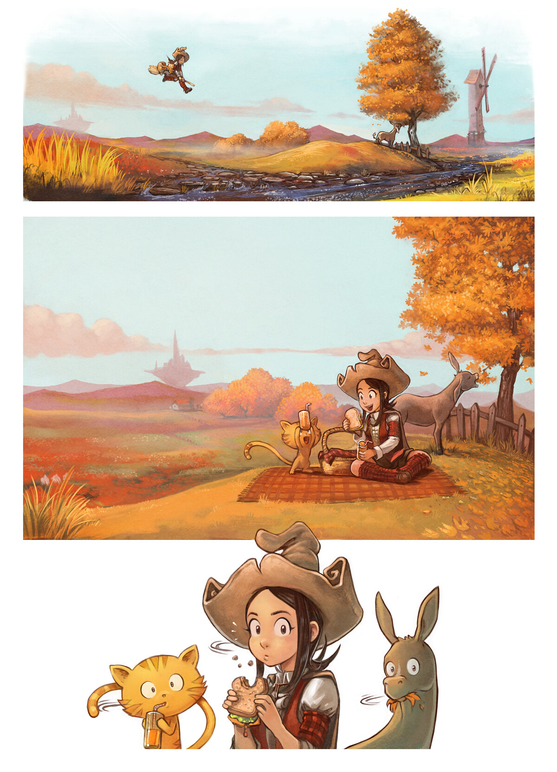

3

1

4

Première version

|  |  |
| --- | --- |
| 1 | ............................................................................................ |
| 2 | ............................................................................................ |
| 3 | ............................................................................................ |
| 4 | ............................................................................................ |
| 5 | ............................................................................................ |

Correction

|  |  |
| --- | --- |
| 1 | ............................................................................................ |
| 2 | ............................................................................................ |
| 3 | ............................................................................................ |
| 4 | ............................................................................................ |
| 5 | ............................................................................................ |

10

8

7

8

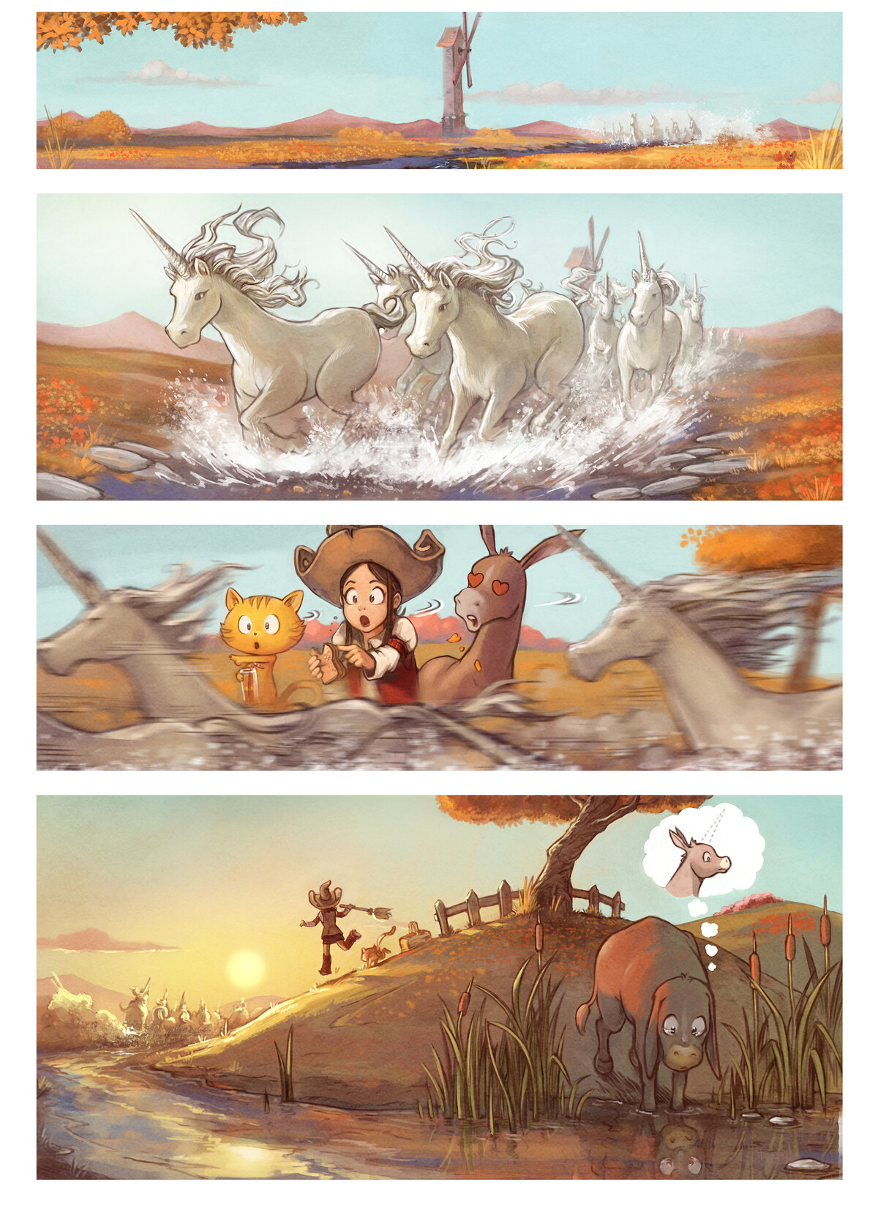

9

6

Première version

|  |  |
| --- | --- |
| 6 | ............................................................................................ |
| 7 | ............................................................................................ |
| 8 | ............................................................................................ |
| 9 | ............................................................................................ |
| 10 | ............................................................................................ |

Correction

|  |  |
| --- | --- |
| 6 | ............................................................................................ |
| 7 | ............................................................................................ |
| 8 | ............................................................................................ |
| 9 | ............................................................................................ |
| 10 | ............................................................................................ |

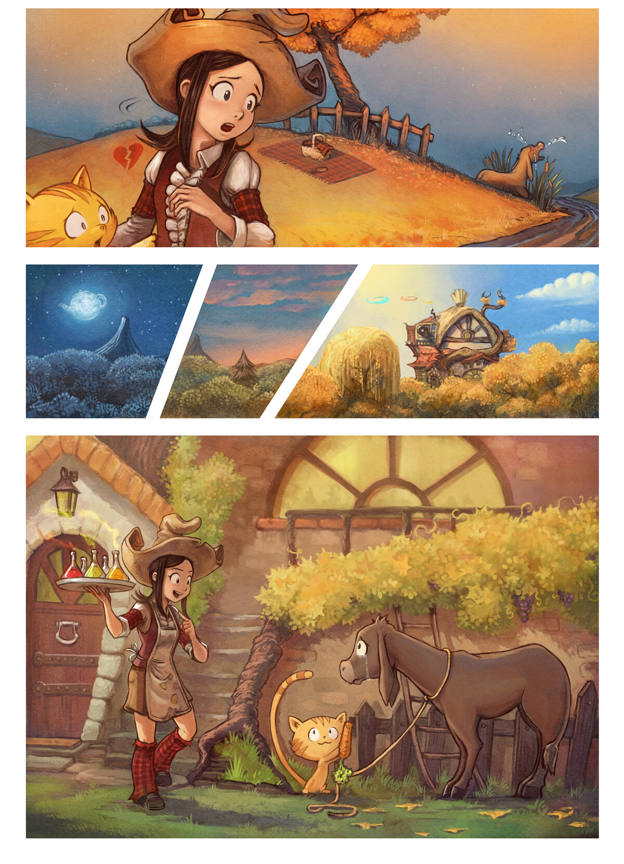

11

Première version

|  |  |
| --- | --- |
| 11 | ............................................................................................ |
| 12 | ............................................................................................ |
| 13 | ............................................................................................ |
| 14 | ............................................................................................ |
| 15 | ............................................................................................ |

Correction

|  |  |
| --- | --- |
| 11 | ............................................................................................ |
| 12 | ............................................................................................ |
| 13 | ............................................................................................ |
| 14 | ............................................................................................ |
| 15 | ............................................................................................ |

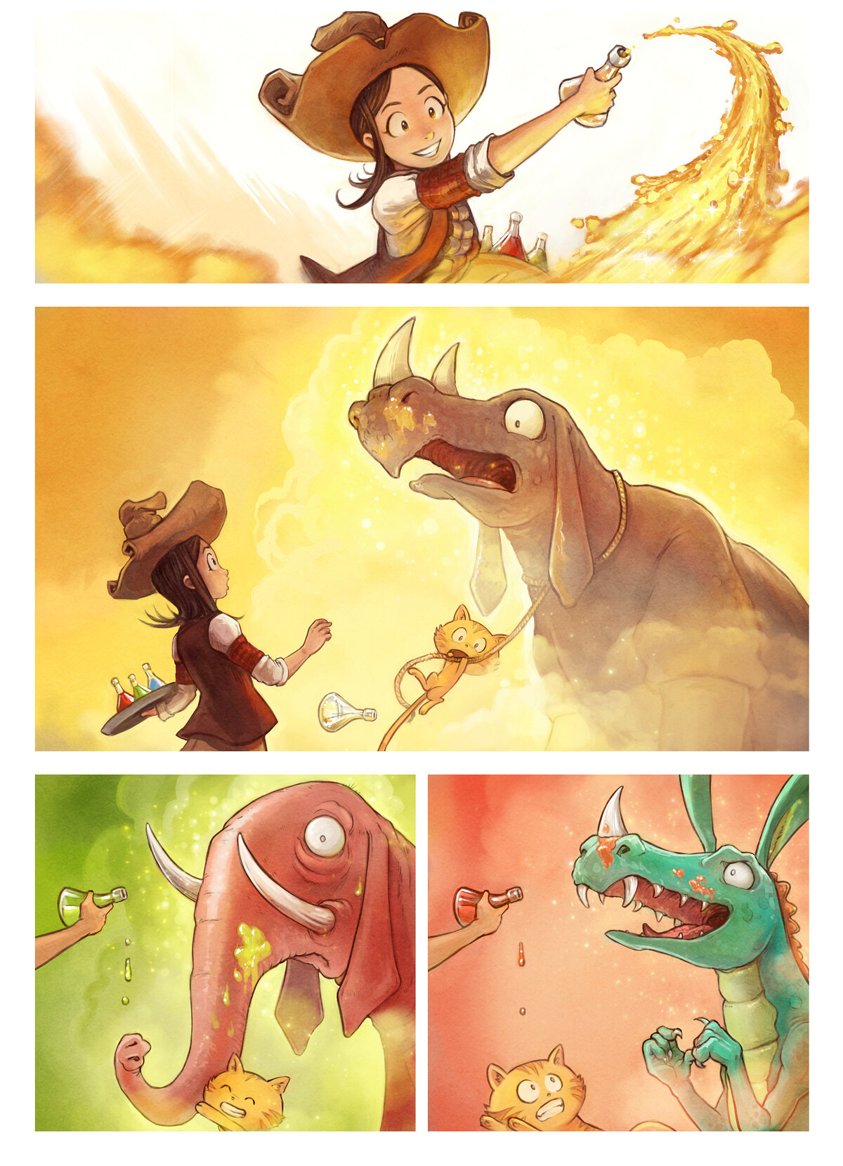

Première version

|  |  |
| --- | --- |
| 1 | ............................................................................................ |
| 2 | ............................................................................................ |
| 3 | ............................................................................................ |
| 4 | ............................................................................................ |
| 5 | ............................................................................................ |

Correction

|  |  |
| --- | --- |
| 1 | ............................................................................................ |
| 2 | ............................................................................................ |
| 3 | ............................................................................................ |
| 4 | ............................................................................................ |
| 5 | ............................................................................................ |

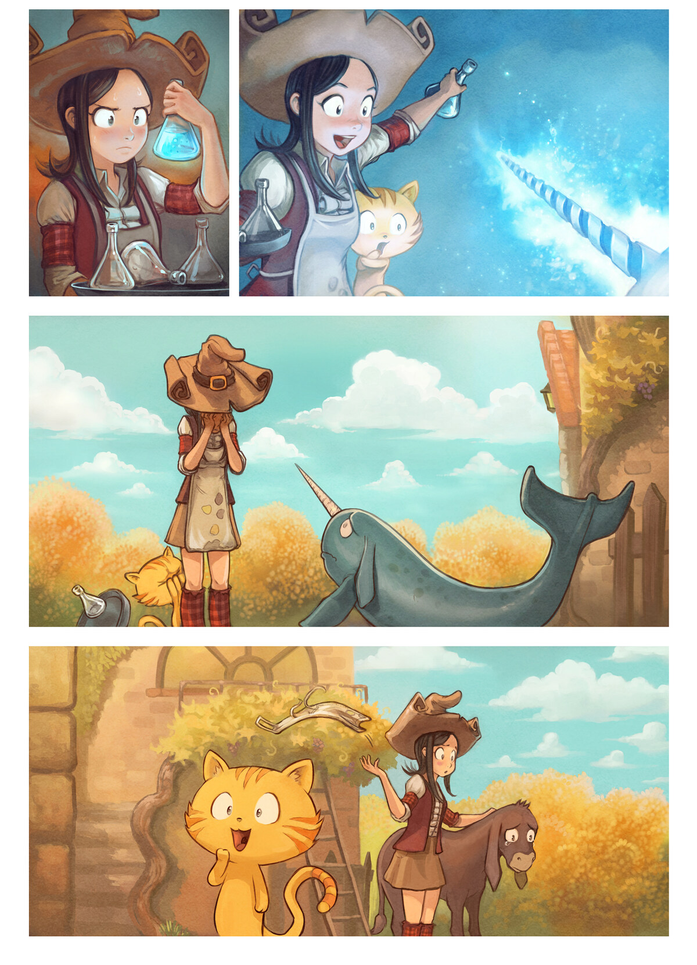

Première version

|  |  |
| --- | --- |
| 1 | ............................................................................................ |
| 2 | ............................................................................................ |
| 3 | ............................................................................................ |
| 4 | ............................................................................................ |
| 5 | ............................................................................................ |

Correction

|  |  |
| --- | --- |
| 1 | ............................................................................................ |
| 2 | ............................................................................................ |
| 3 | ............................................................................................ |
| 4 | ............................................................................................ |
| 5 | ............................................................................................ |

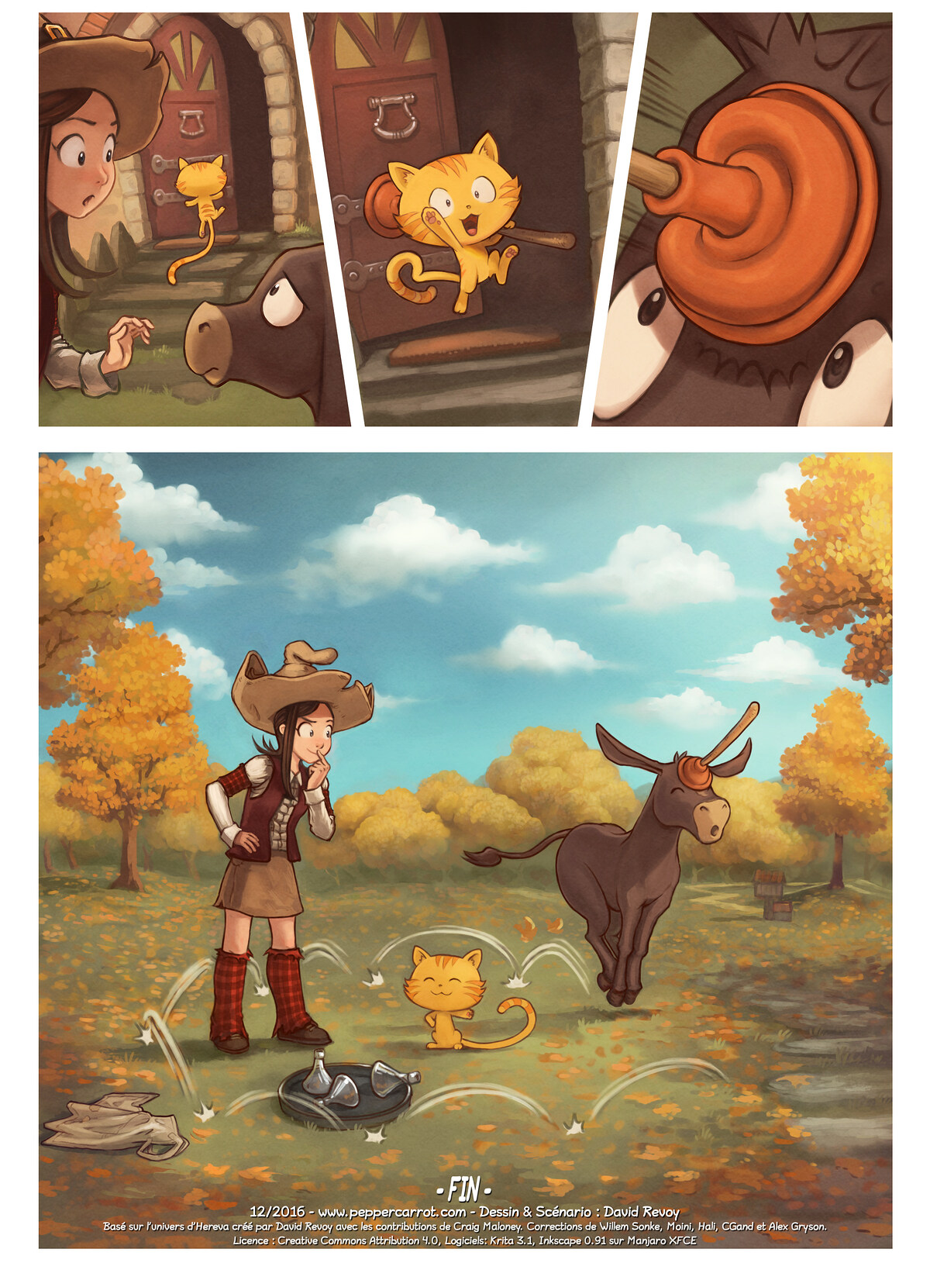

Première version

|  |  |
| --- | --- |
| 1 | ............................................................................................ |
| 2 | ............................................................................................ |
| 3 | ............................................................................................ |
| 4 | ............................................................................................ |
| 5 | ............................................................................................ |

Correction

|  |  |
| --- | --- |
| 1 | ............................................................................................ |
| 2 | ............................................................................................ |
| 3 | ............................................................................................ |
| 4 | ............................................................................................ |
| 5 | ............................................................................................ |

Lexique :

Associe le bon terme avec la bonne lettre :

phylactère, cartouche, case, planche, bande

|  |  |
| --- | --- |
| A  .......................................................  B  .......................................................  C  ....................................................... | A  B  C |
| D  .......................................................  E  .......................................................  F  ....................................................... | F  E  D |

Copyright © David Revoy 2021.

www.peppercarrot.com

This work is licensed under a Creative Commons Attribution 4.0 International license.

The text of the license is available at https://creativecommons.org/licenses/by/4.0/.

Épisode 20 : Le Pique-nique (published on 2016-12-17)

Art: David Revoy. Scenario: David Revoy.

Français (original version)