

TIME: 5 Mins

Safe Driving

* When driving along Hollinsworth Rd from the IKEA roundabout the NSW traffic legislation does not permit you to drive on the ***wrong side*** of the road to access the Lindt carpark 2
* There are a set of traffic lights north of McDonalds that you can take from Richmond Road which will take you to the western side of the site and allow safe access into the carpark

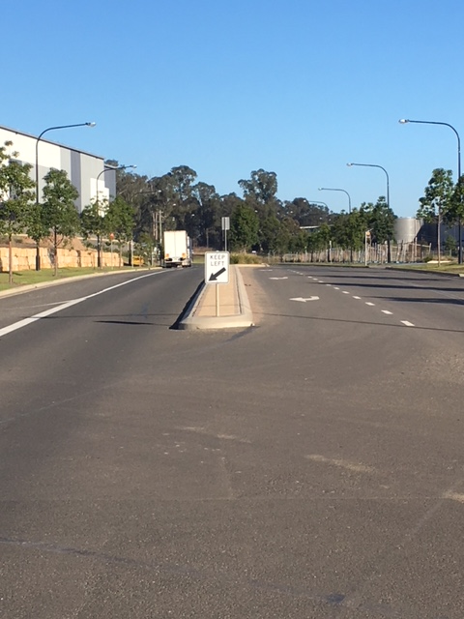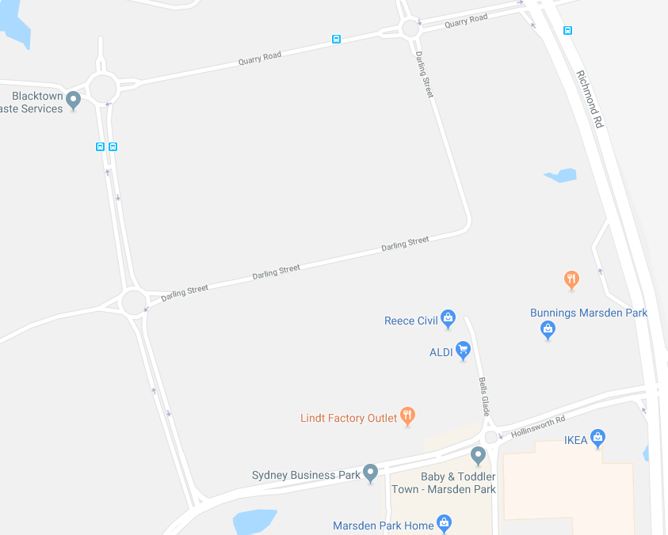

***“Sharing HSE learning’s amongst Lindt Staff”***

TIME: 5 Mins

